**RDBMS PROJECT**

**TOPIC: PIZZA DILIVERY MANAGEMENT SYSTEM**

**BY:**

**1.JAYESH SHELAR (1606109)**

**2.RAKESH SHINDE (1606112)**

**3.SHREYAS MANTE (1606116)**

**4.DHIRAJ SURVE (1606118)**

**Creating a Table:**

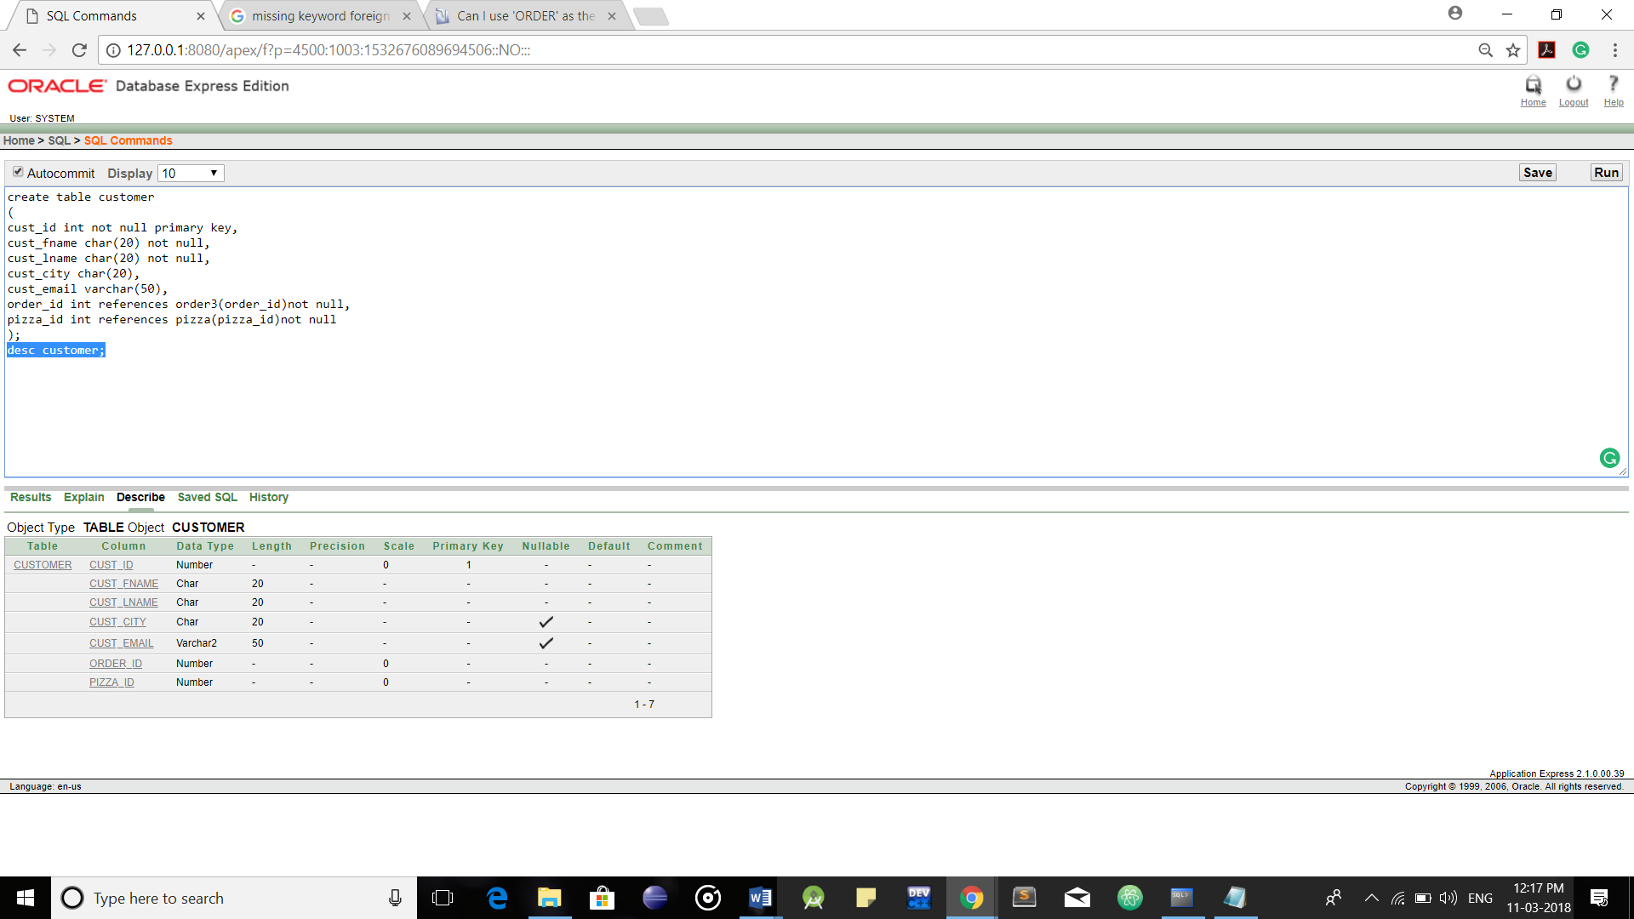

**Primary Key and Foreign Keys:**

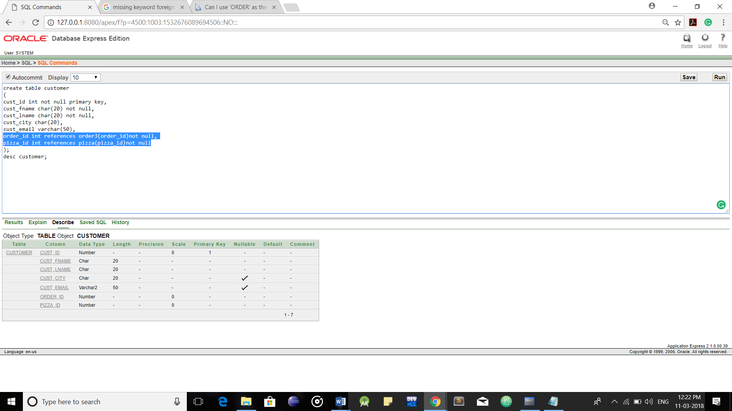

Primary Key

Foreign Keys

**Inserting Data into Tables:**

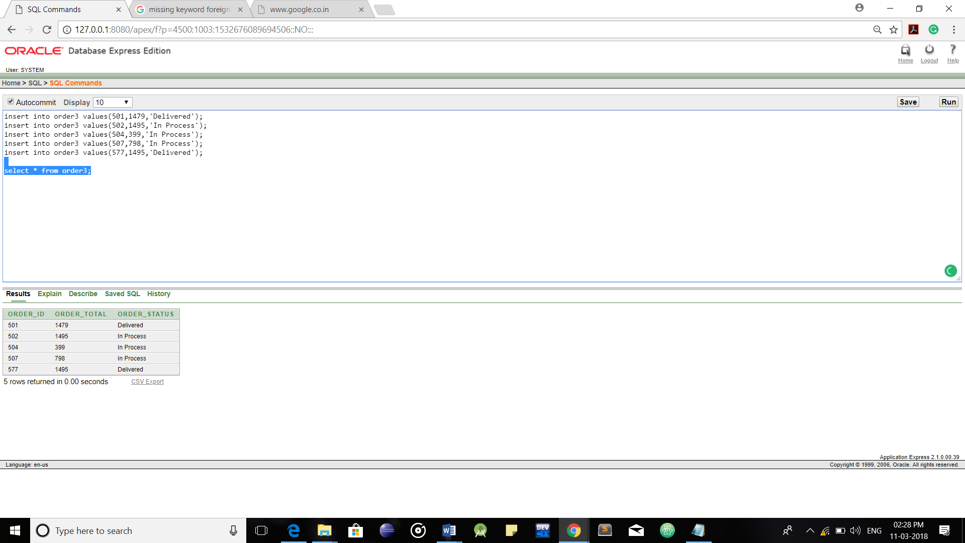

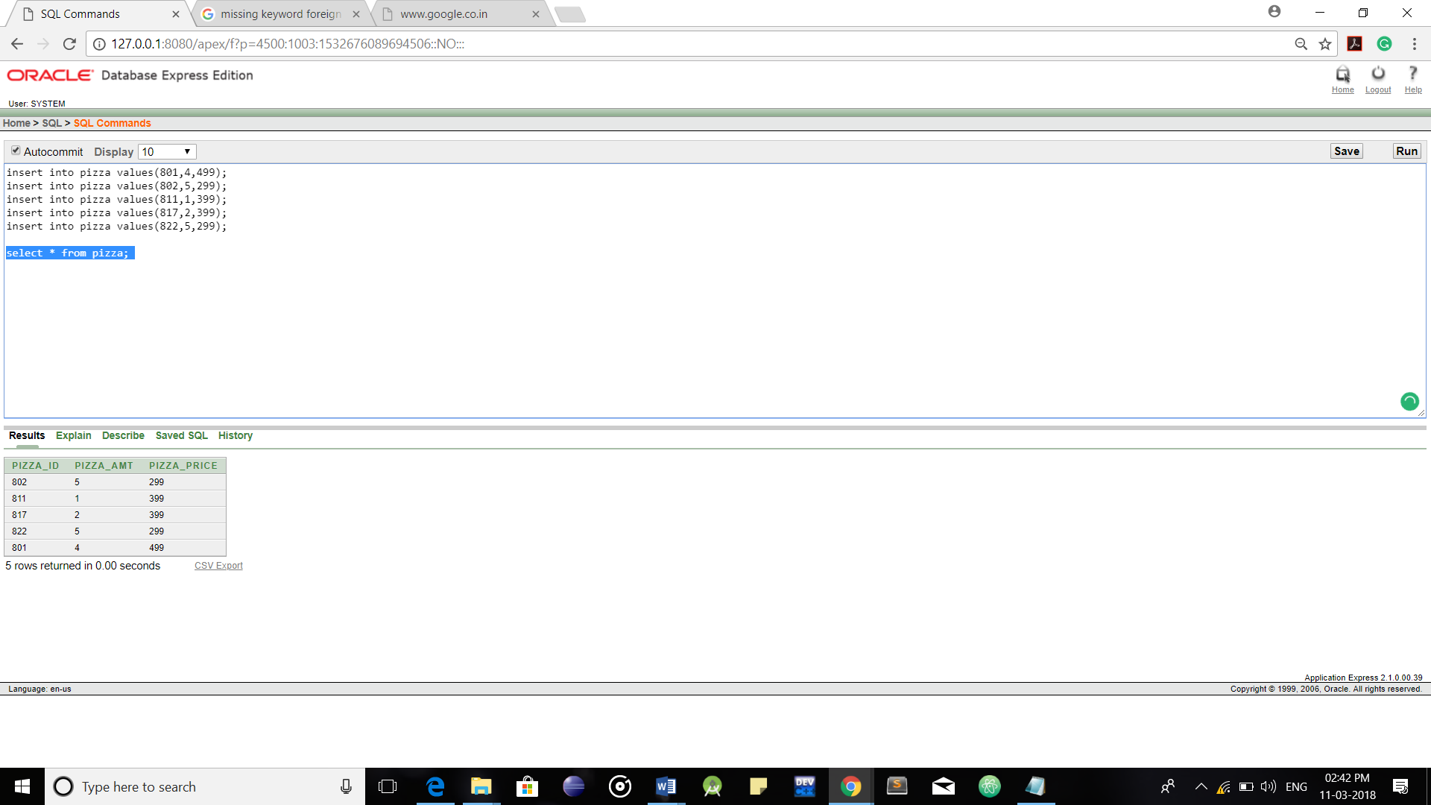

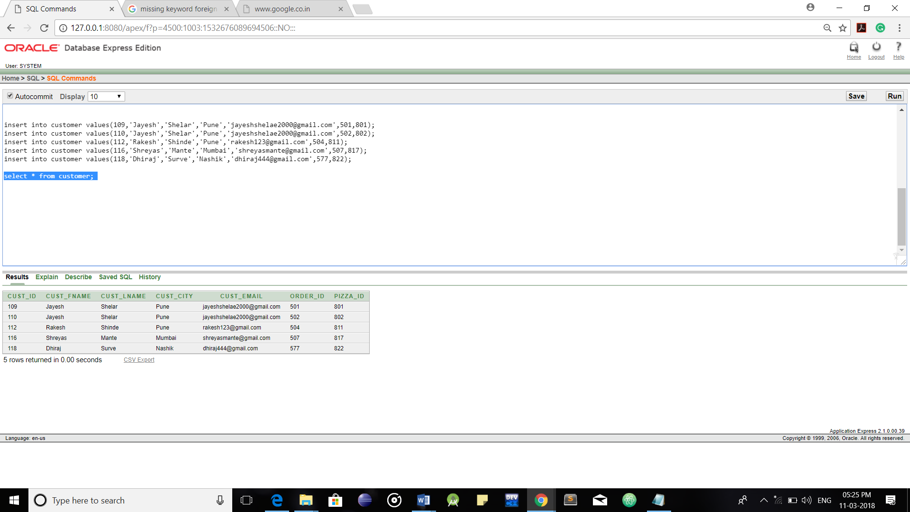

**Updating Contents of Table:**

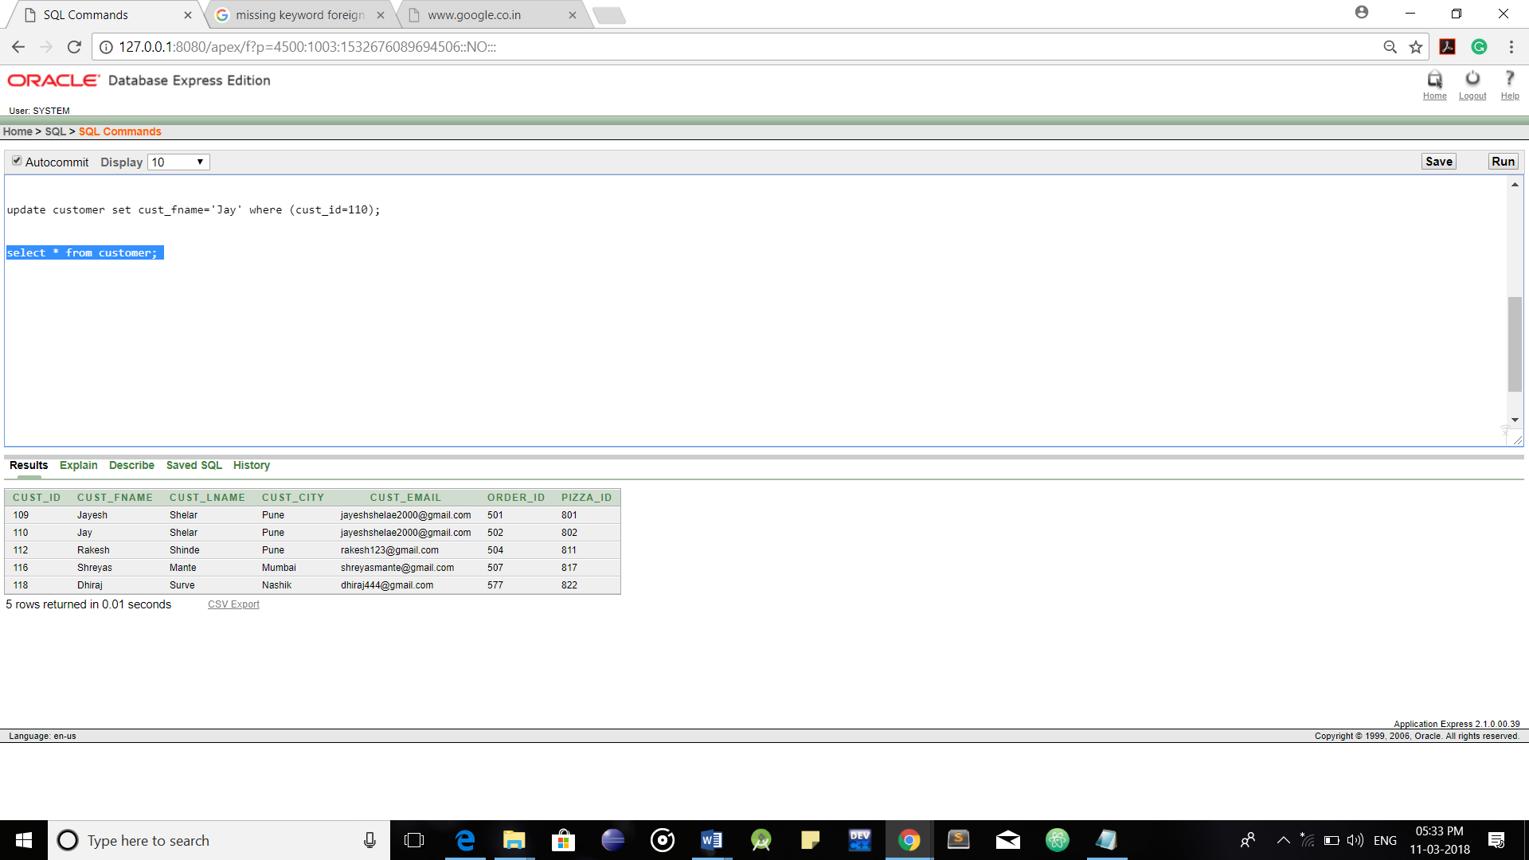

**Deleting contents from Table:**

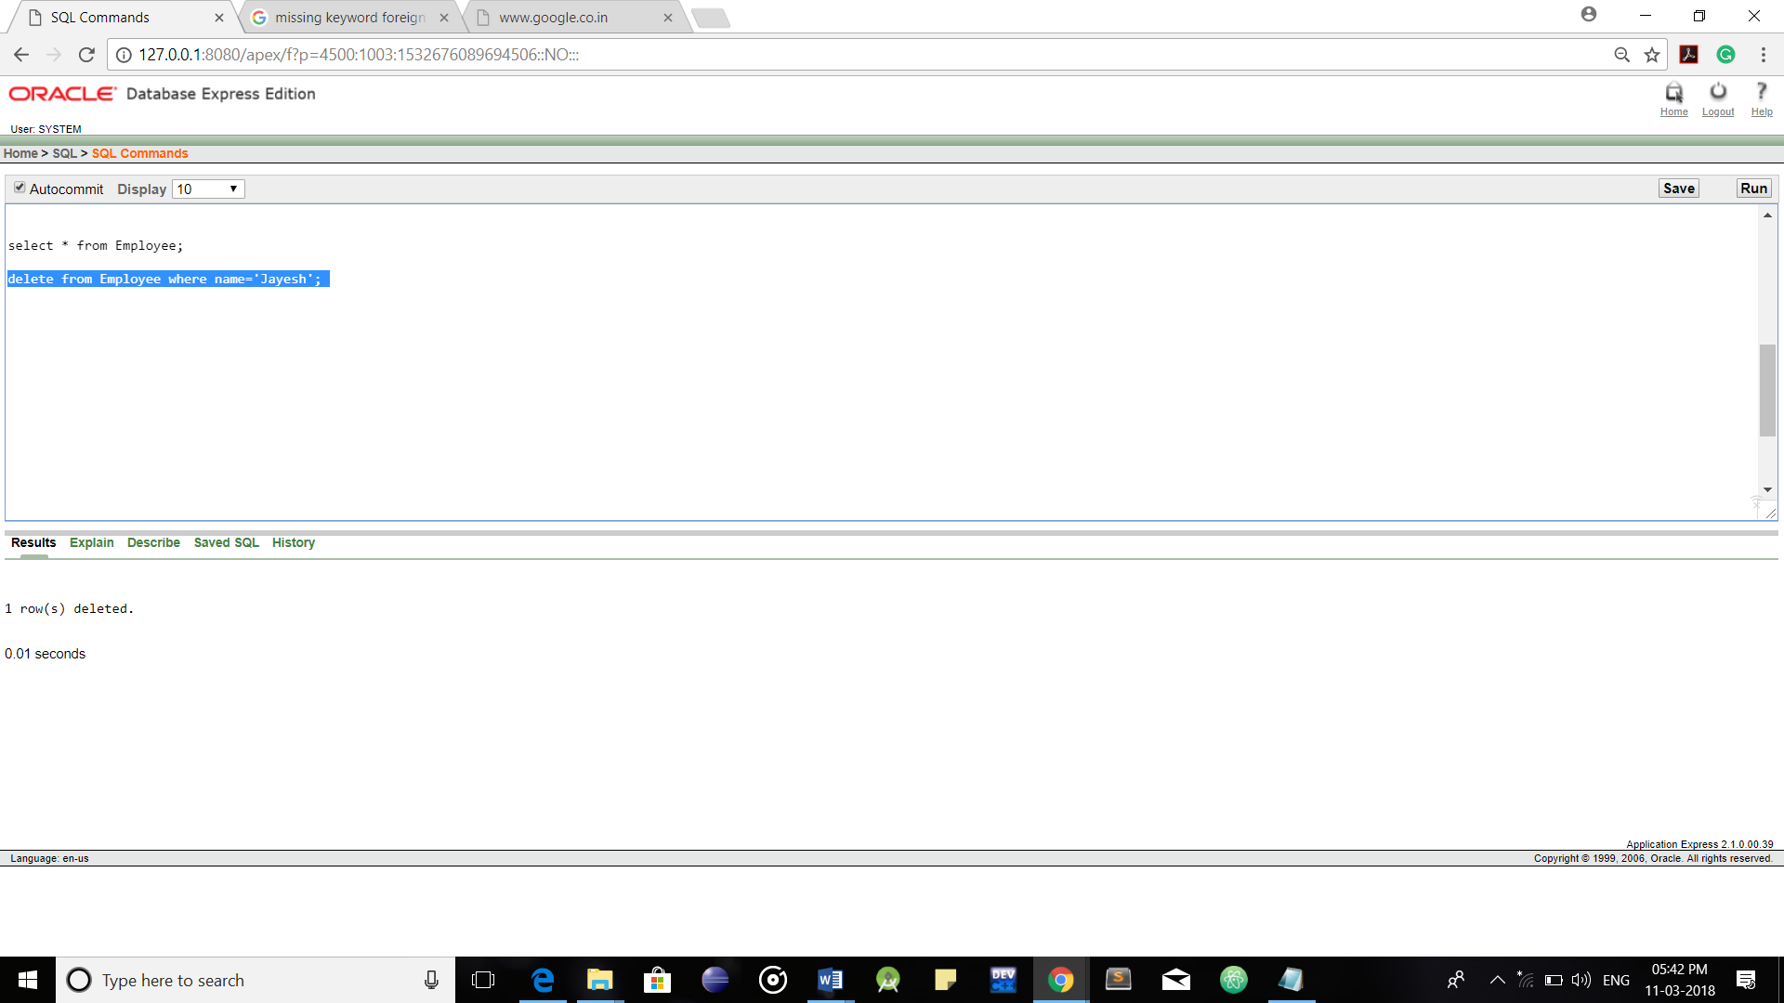

**Renaming Table Name:**

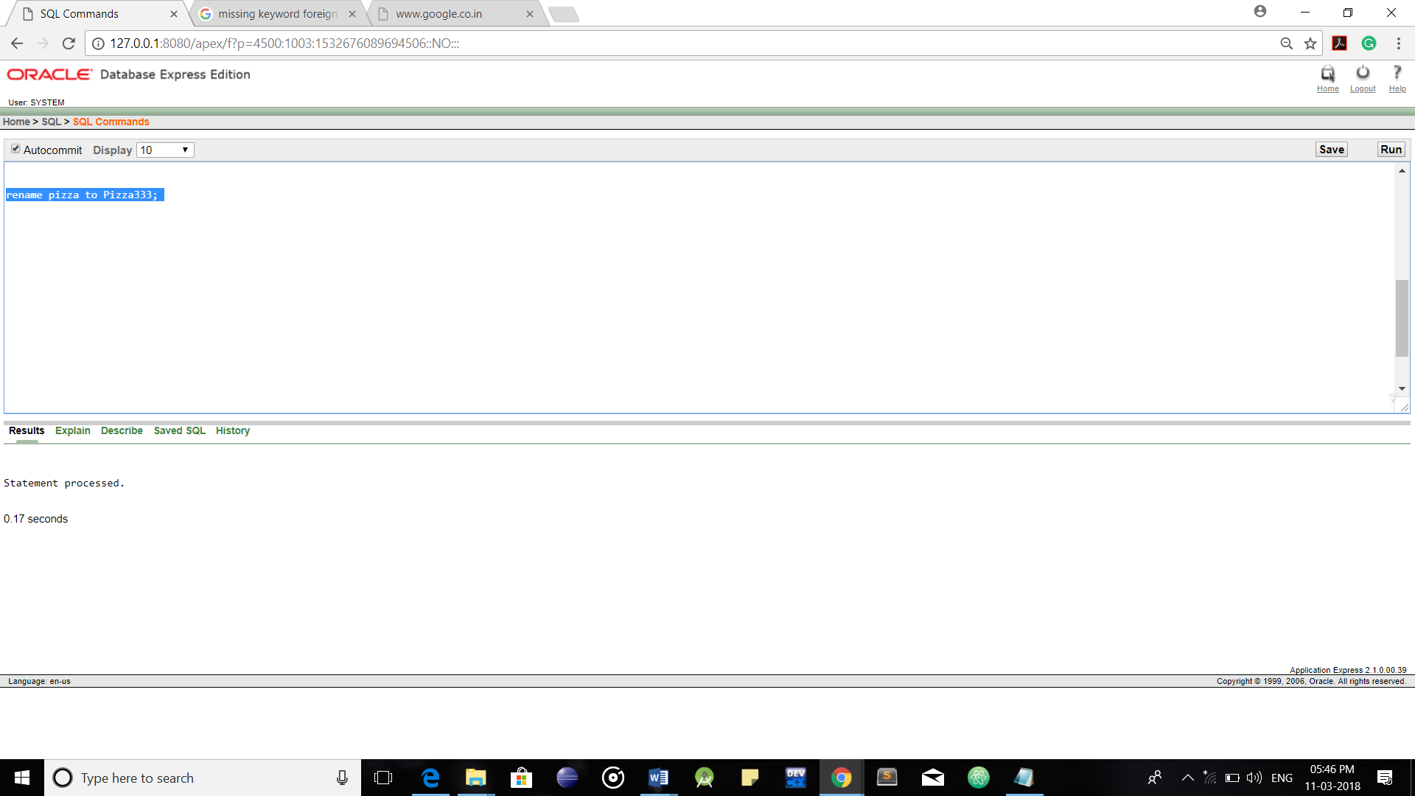

**Constraints:**

**Constraints**

Not Null Constraints

Foreign Key Constraints

Unique Key Constraints

Primary Key Constraints

Key Constraints

Referential Integrity Constraints

Entity Integrity Constraints

Domain Integrity

**Key Constraints:**

**1.Primary Key Constraints:**

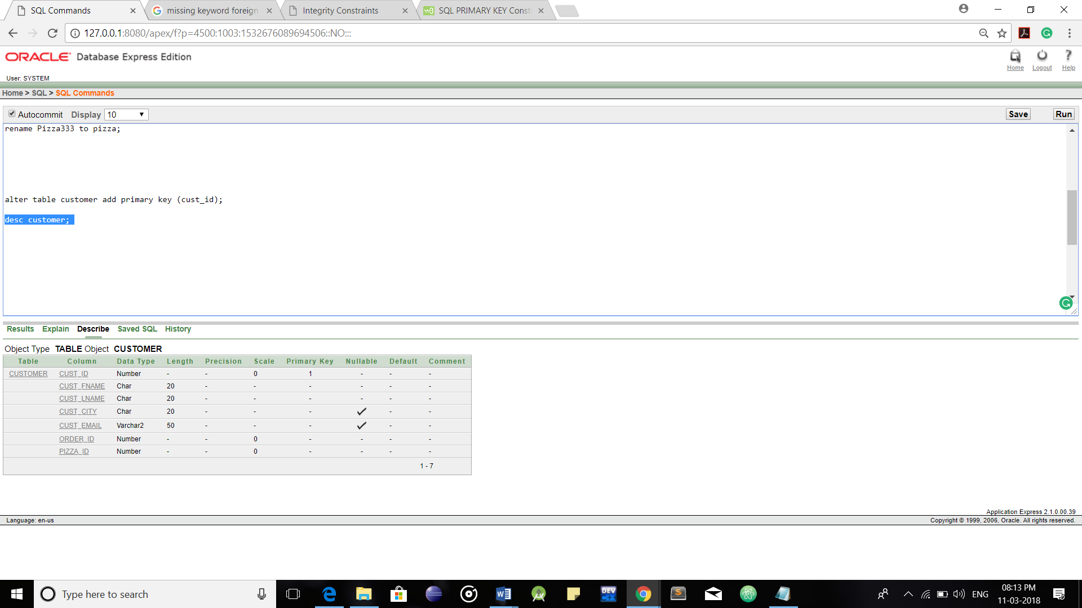

**2.Unique Key Constraints:**

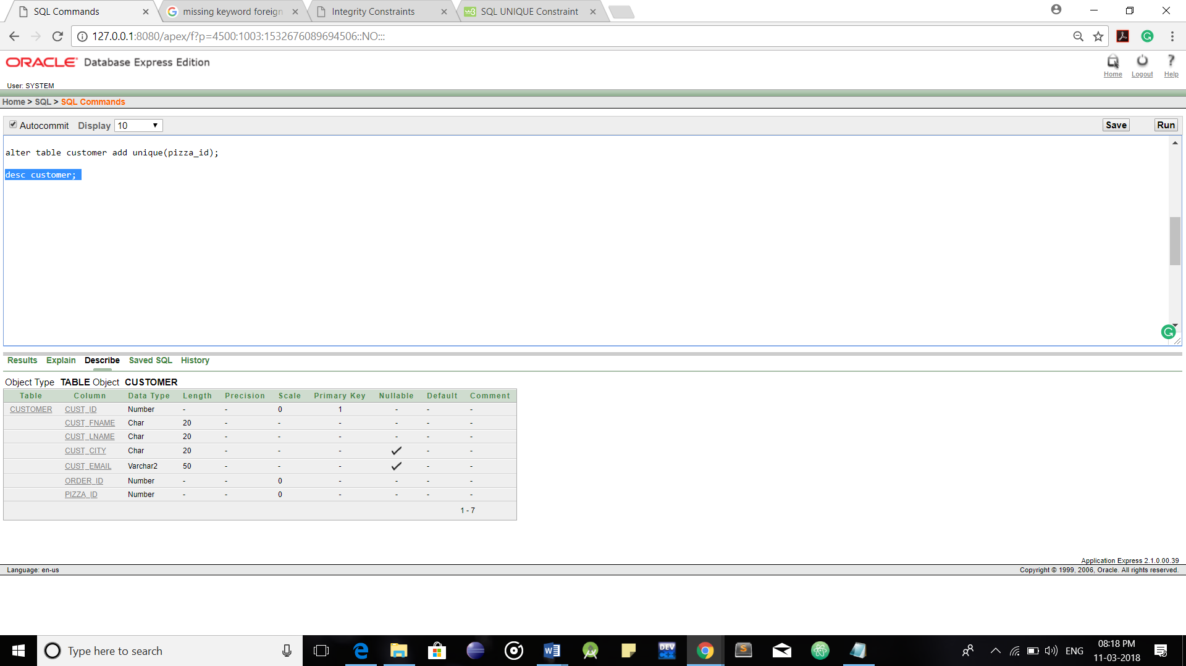

**3.Foreign Key Constraint:**



Foreign Keys

**4.Not Null Constraint:**

**Tip:** If the table has already been created, you can add a NOT NULL constraint to a column with the [ALTER TABLE](https://www.w3schools.com/sql/sql_alter.asp) statement.



Not Null Constraints

**Operators in SQL:**

**1.Comparison/Relational Operators**

**2.Logical & Conjunctive Operators**

**3.Operators for Negating Conditions**

**4.Arithmetic Operators**

**1.Comparison/Relational Operators:**

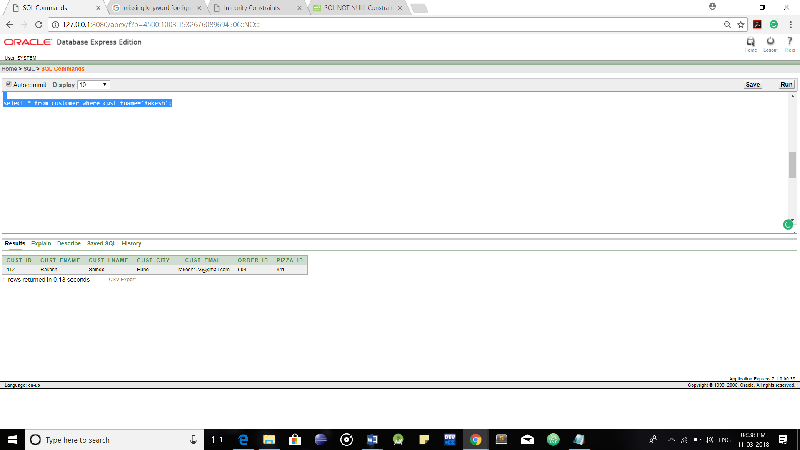

Equality Operator

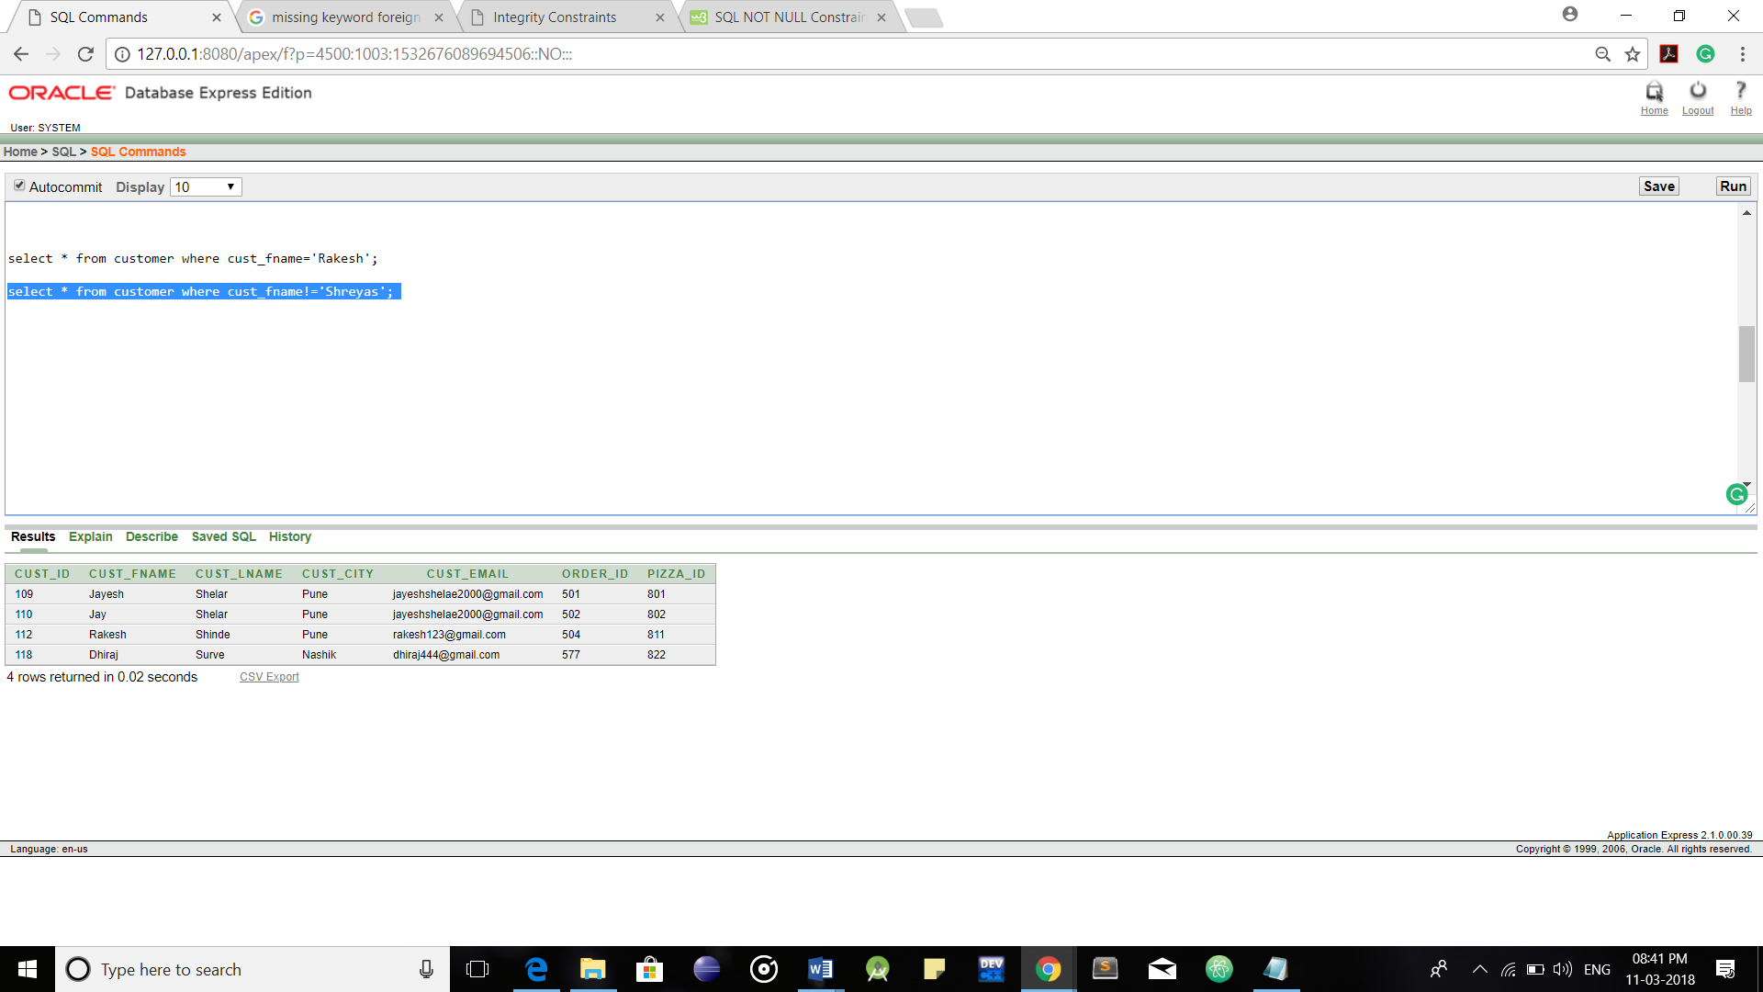

Non-Equality Operator

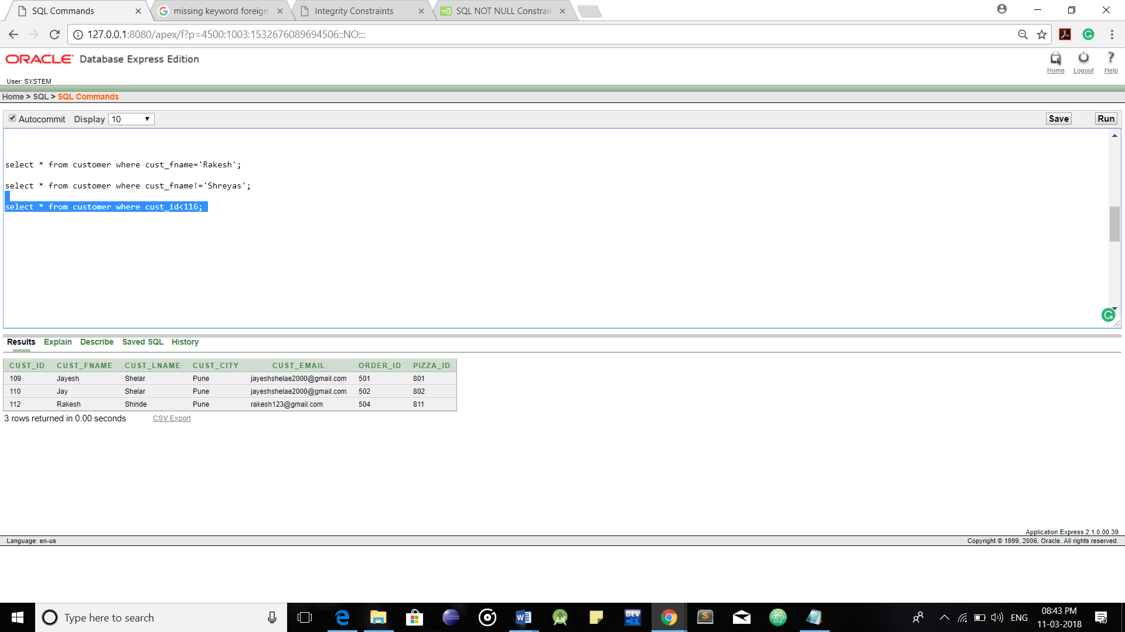

Less-than Operator

**2.Logical Operators:**

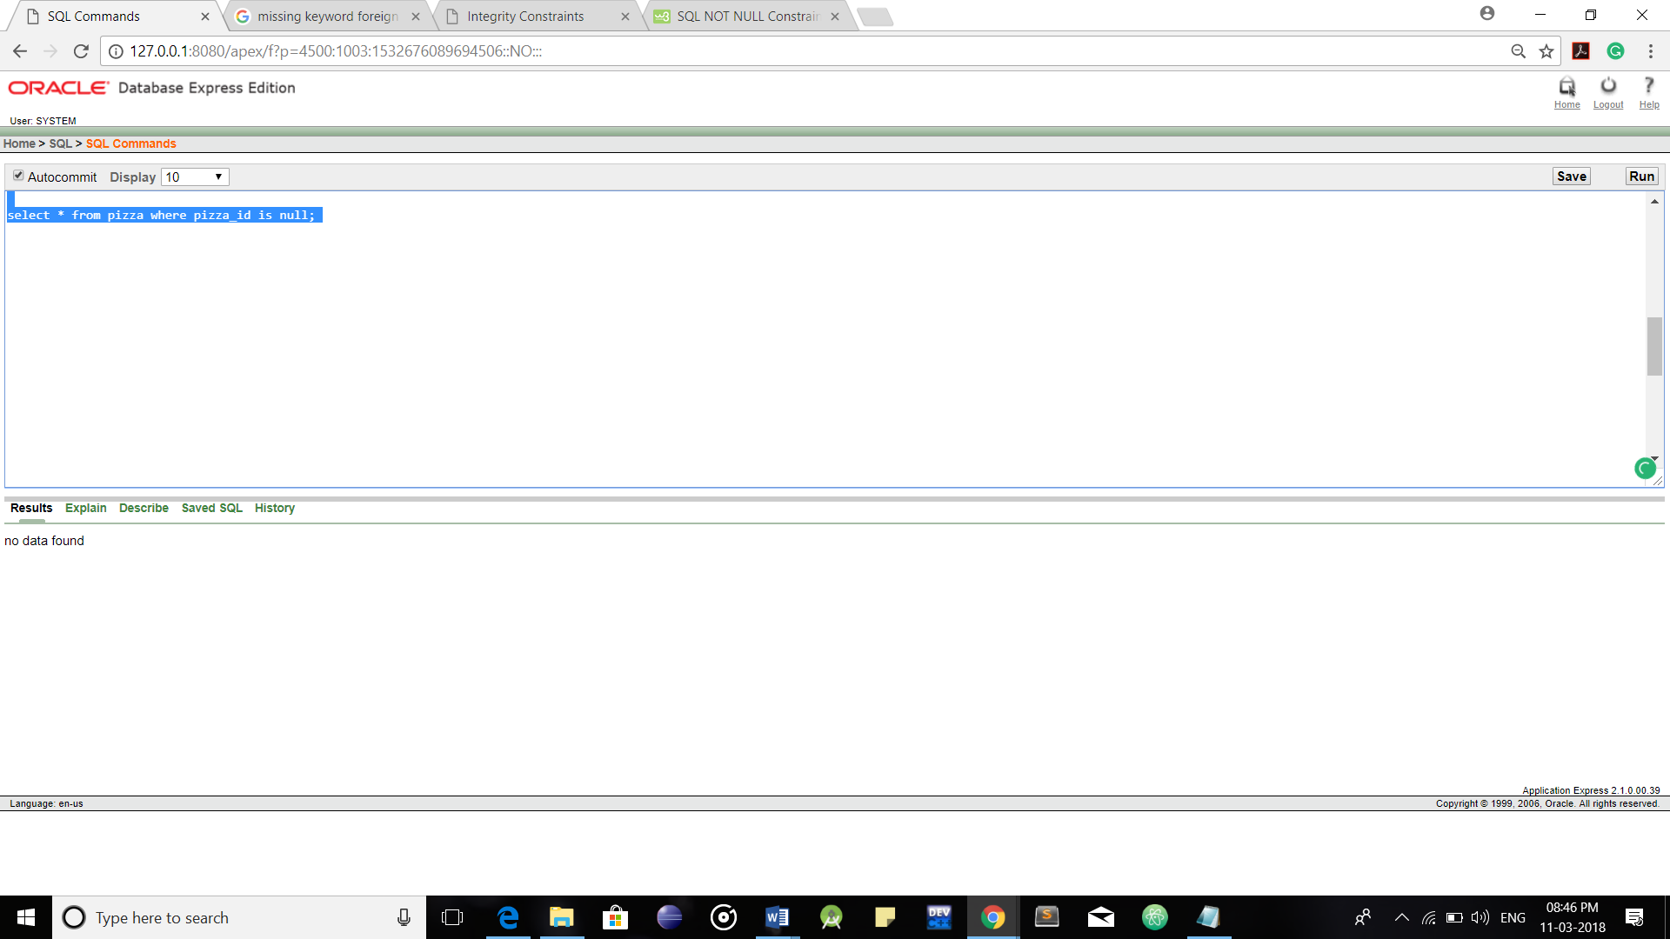

Is-Null Operator

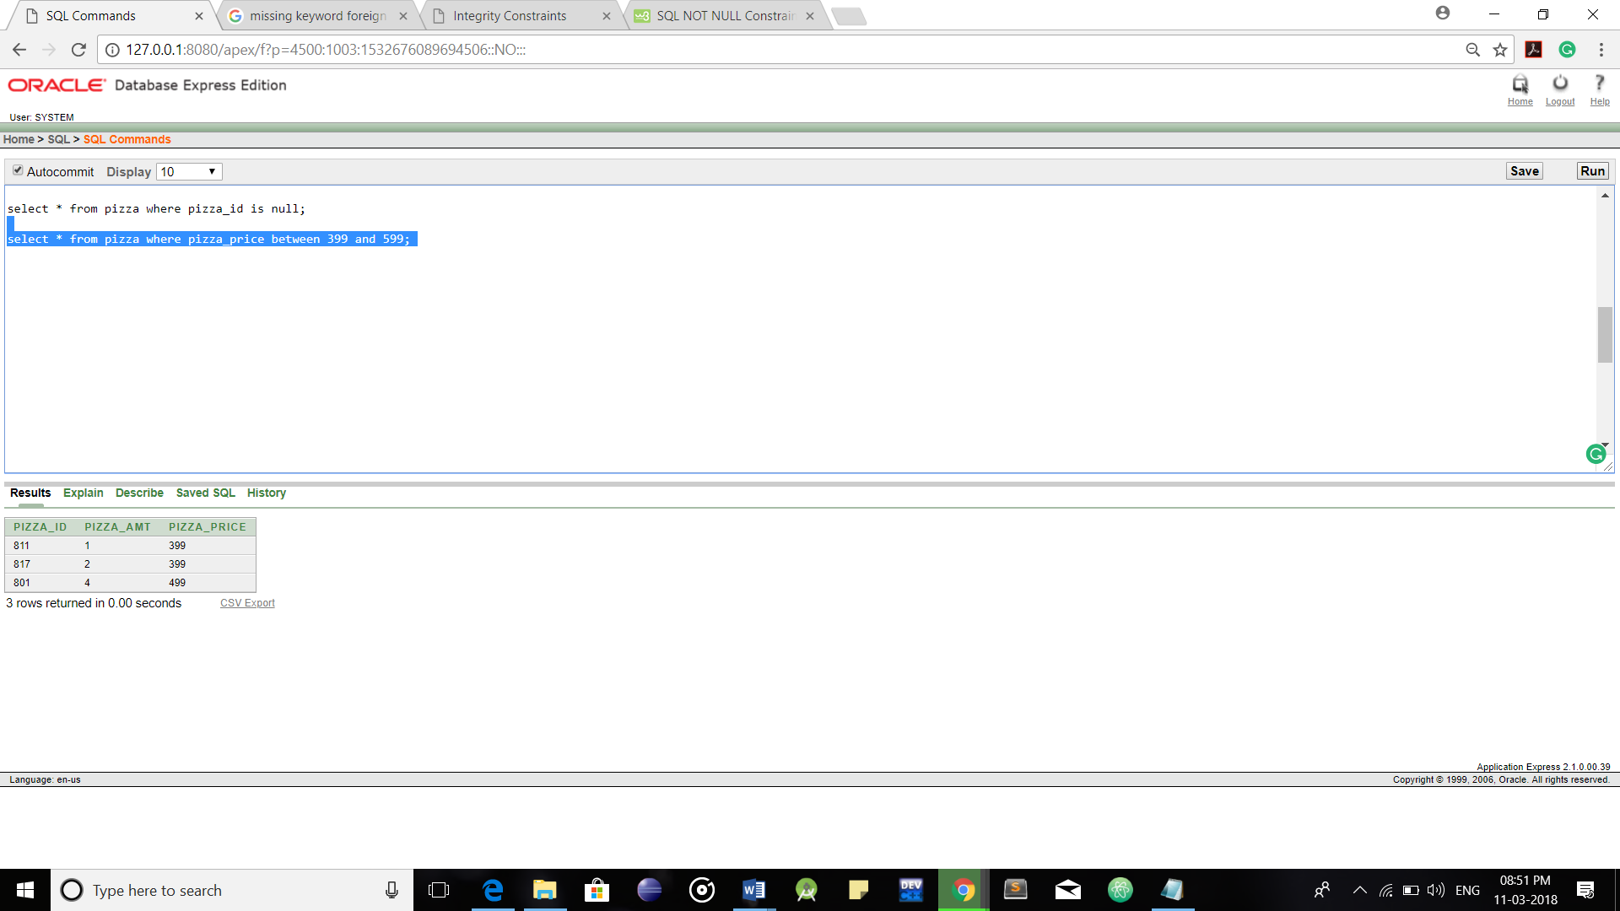

Between Operator

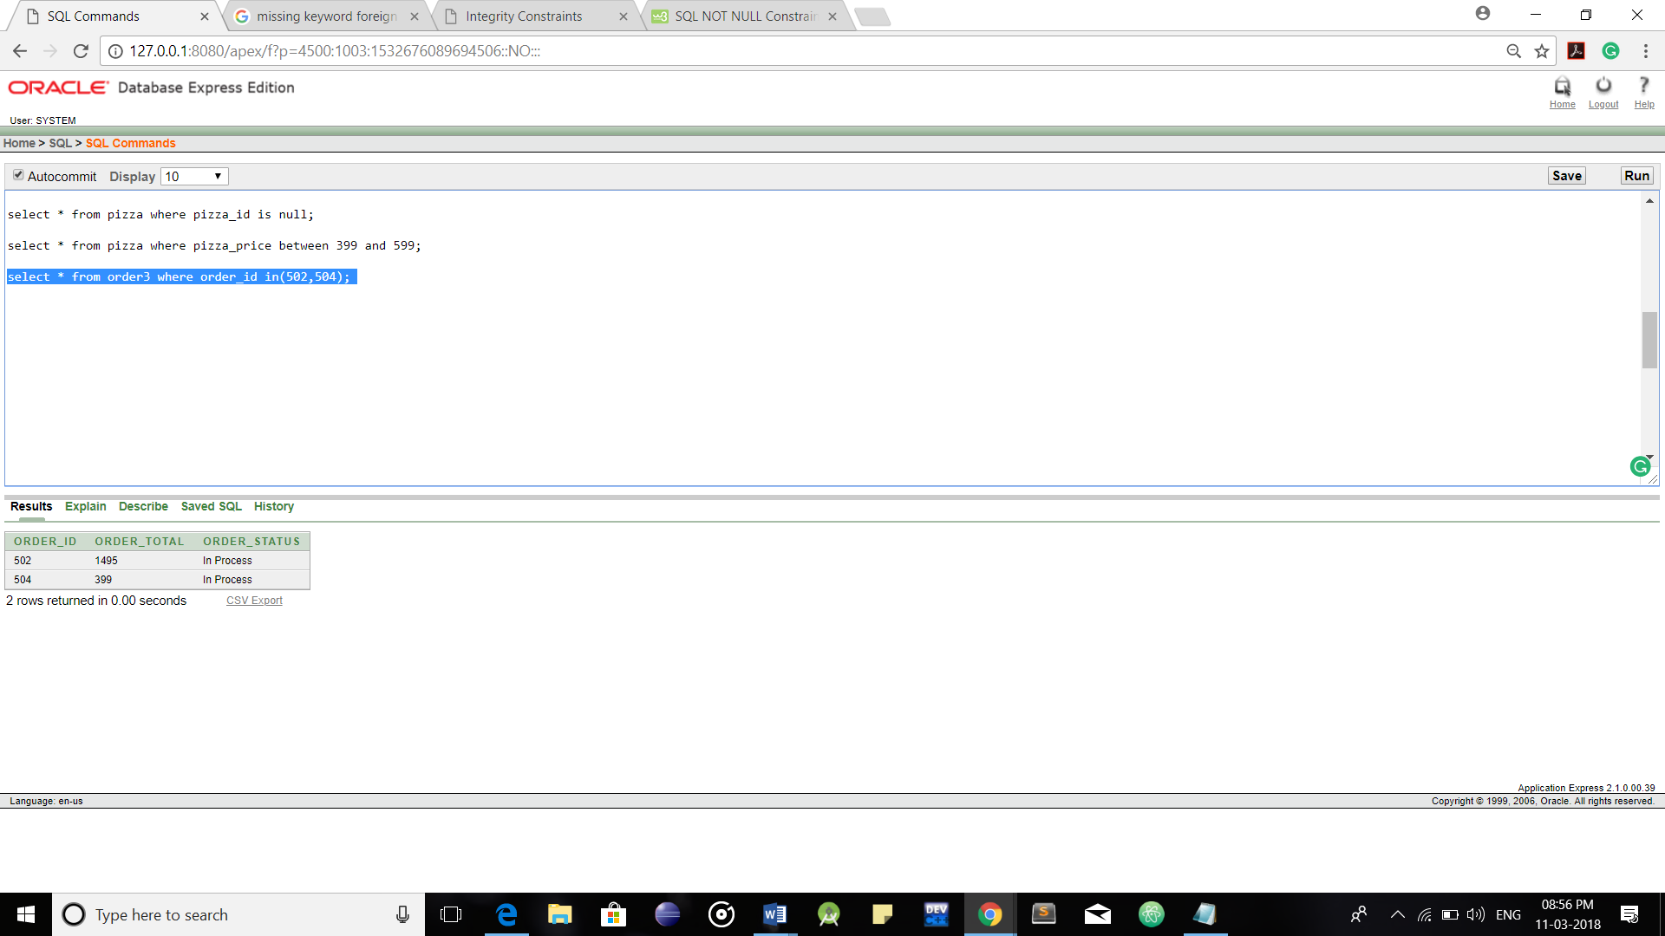

IN Operator

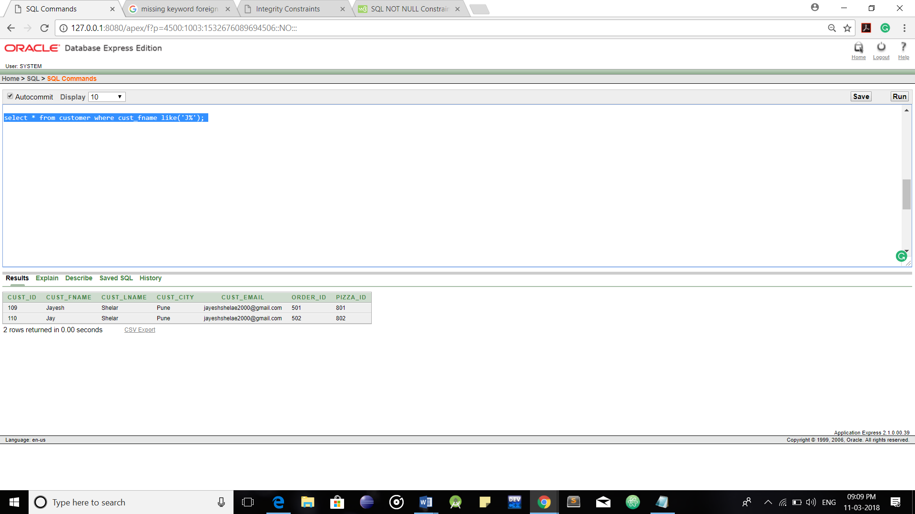

Like Operator

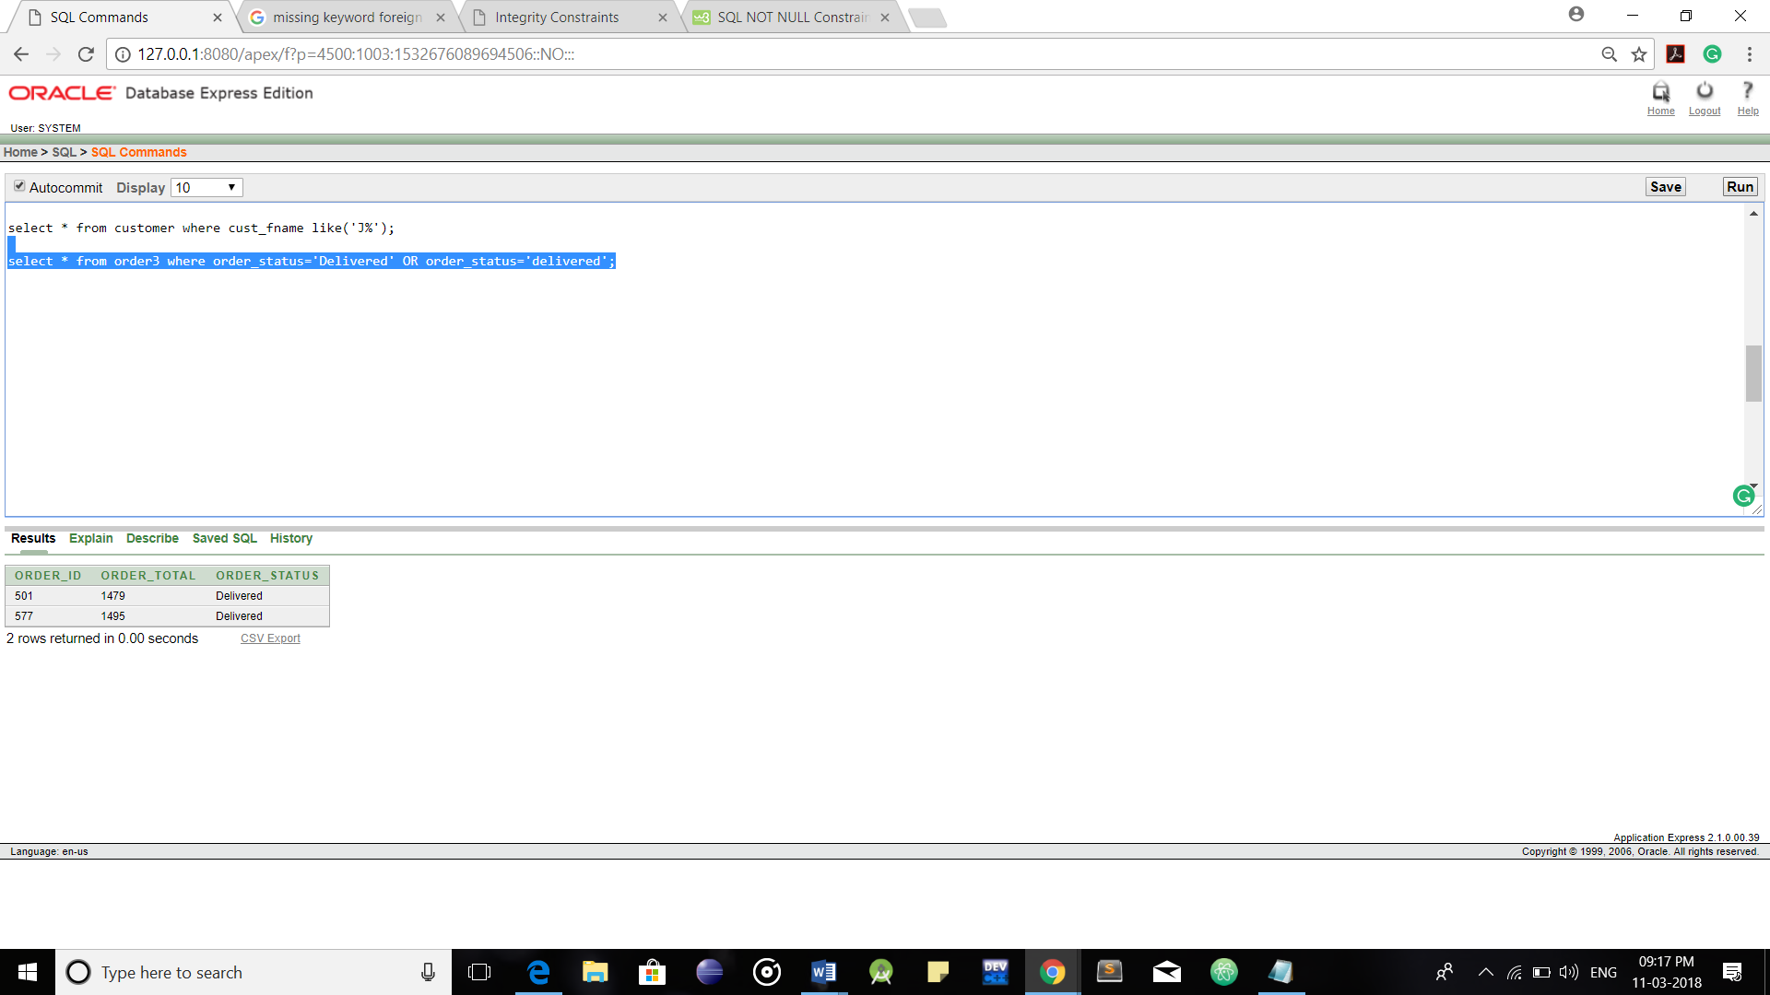

Conjunctive OR Operator

**3.Operators for Negating Conditions:**

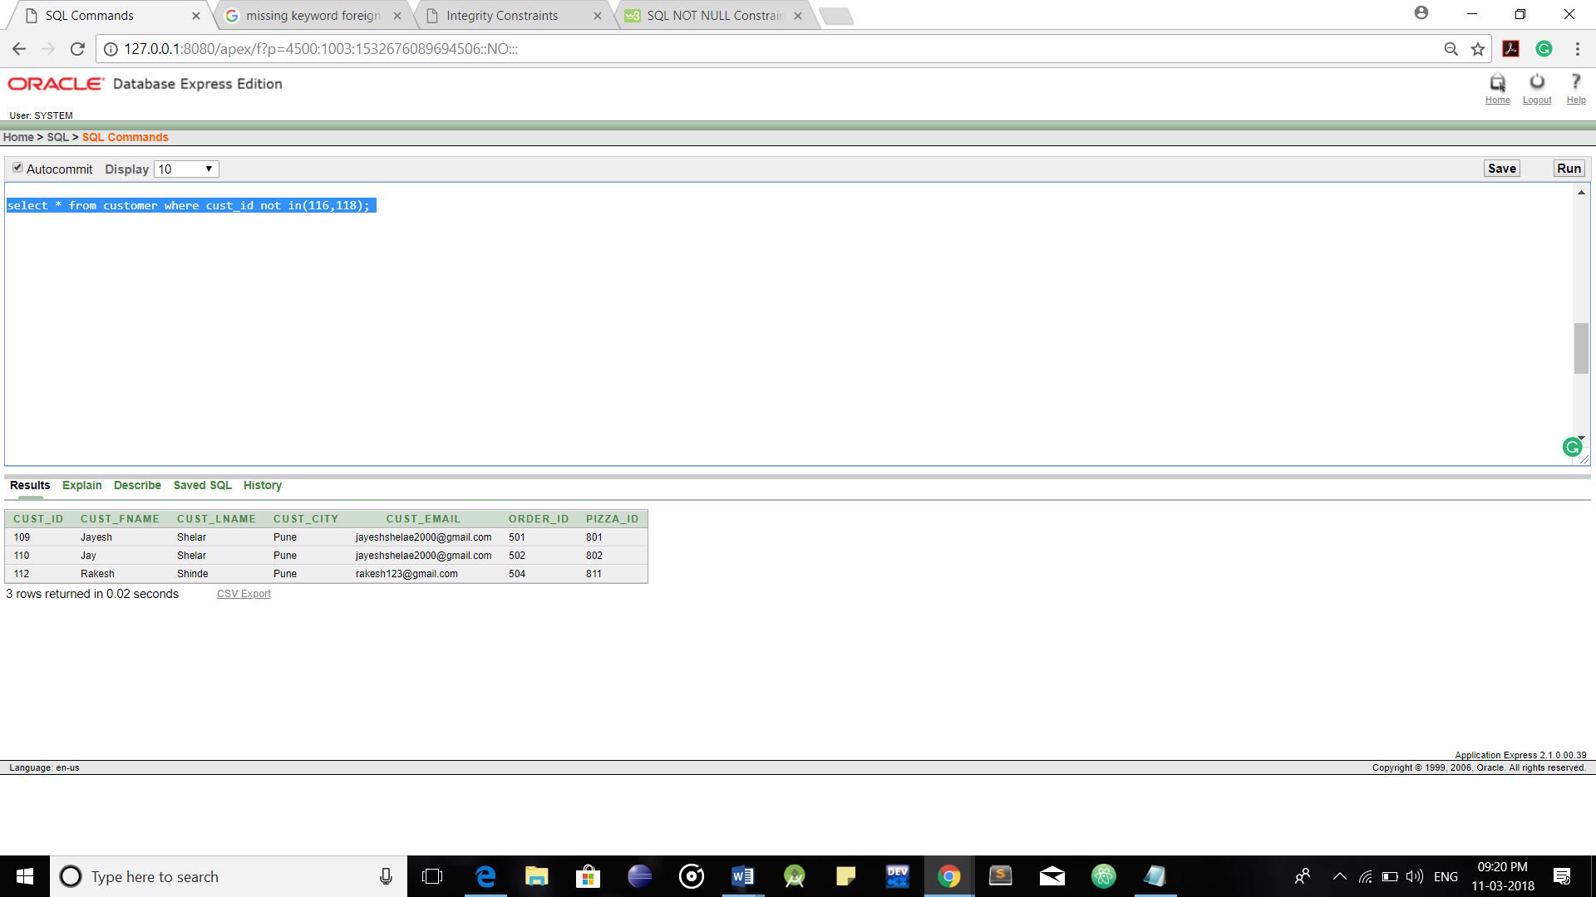

Negating NOT Operator

**4.Arithmetic Operators:**

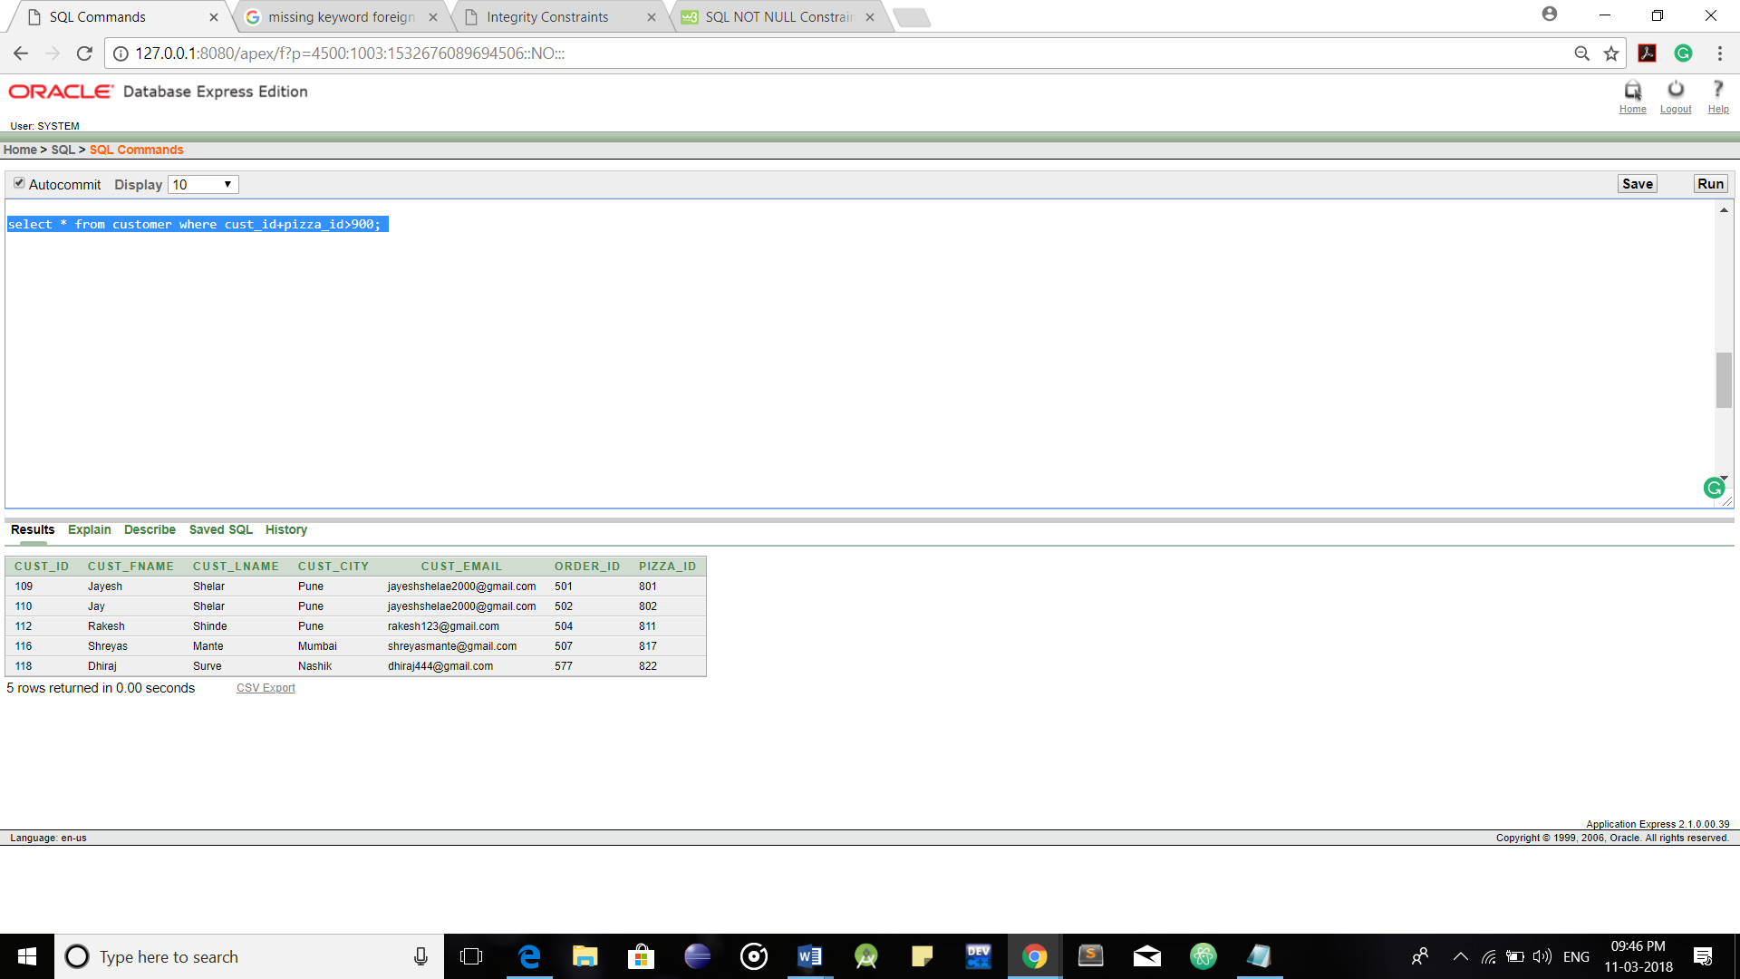

Addition Operator

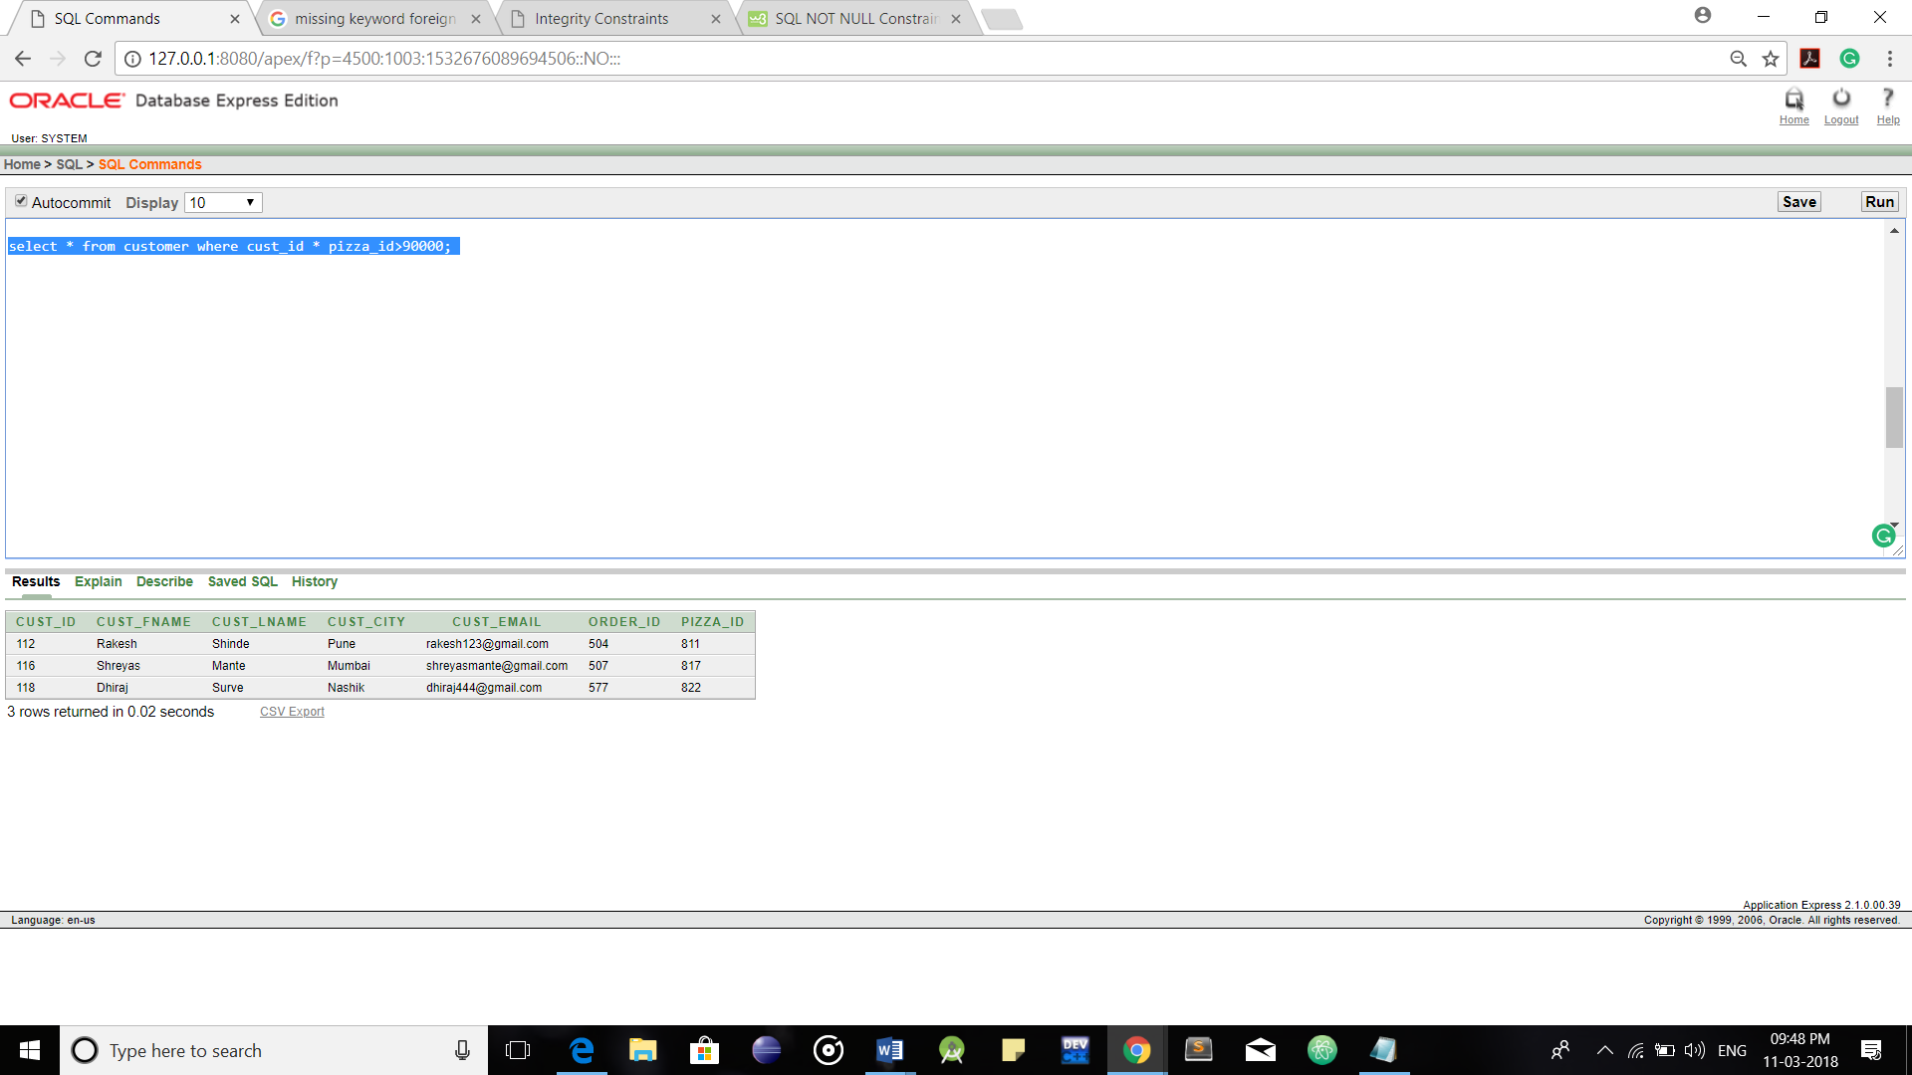

Multiplication Operator

**Functions in SQL:**

**1.Aggregate Functions:**

**1)Count Function:**

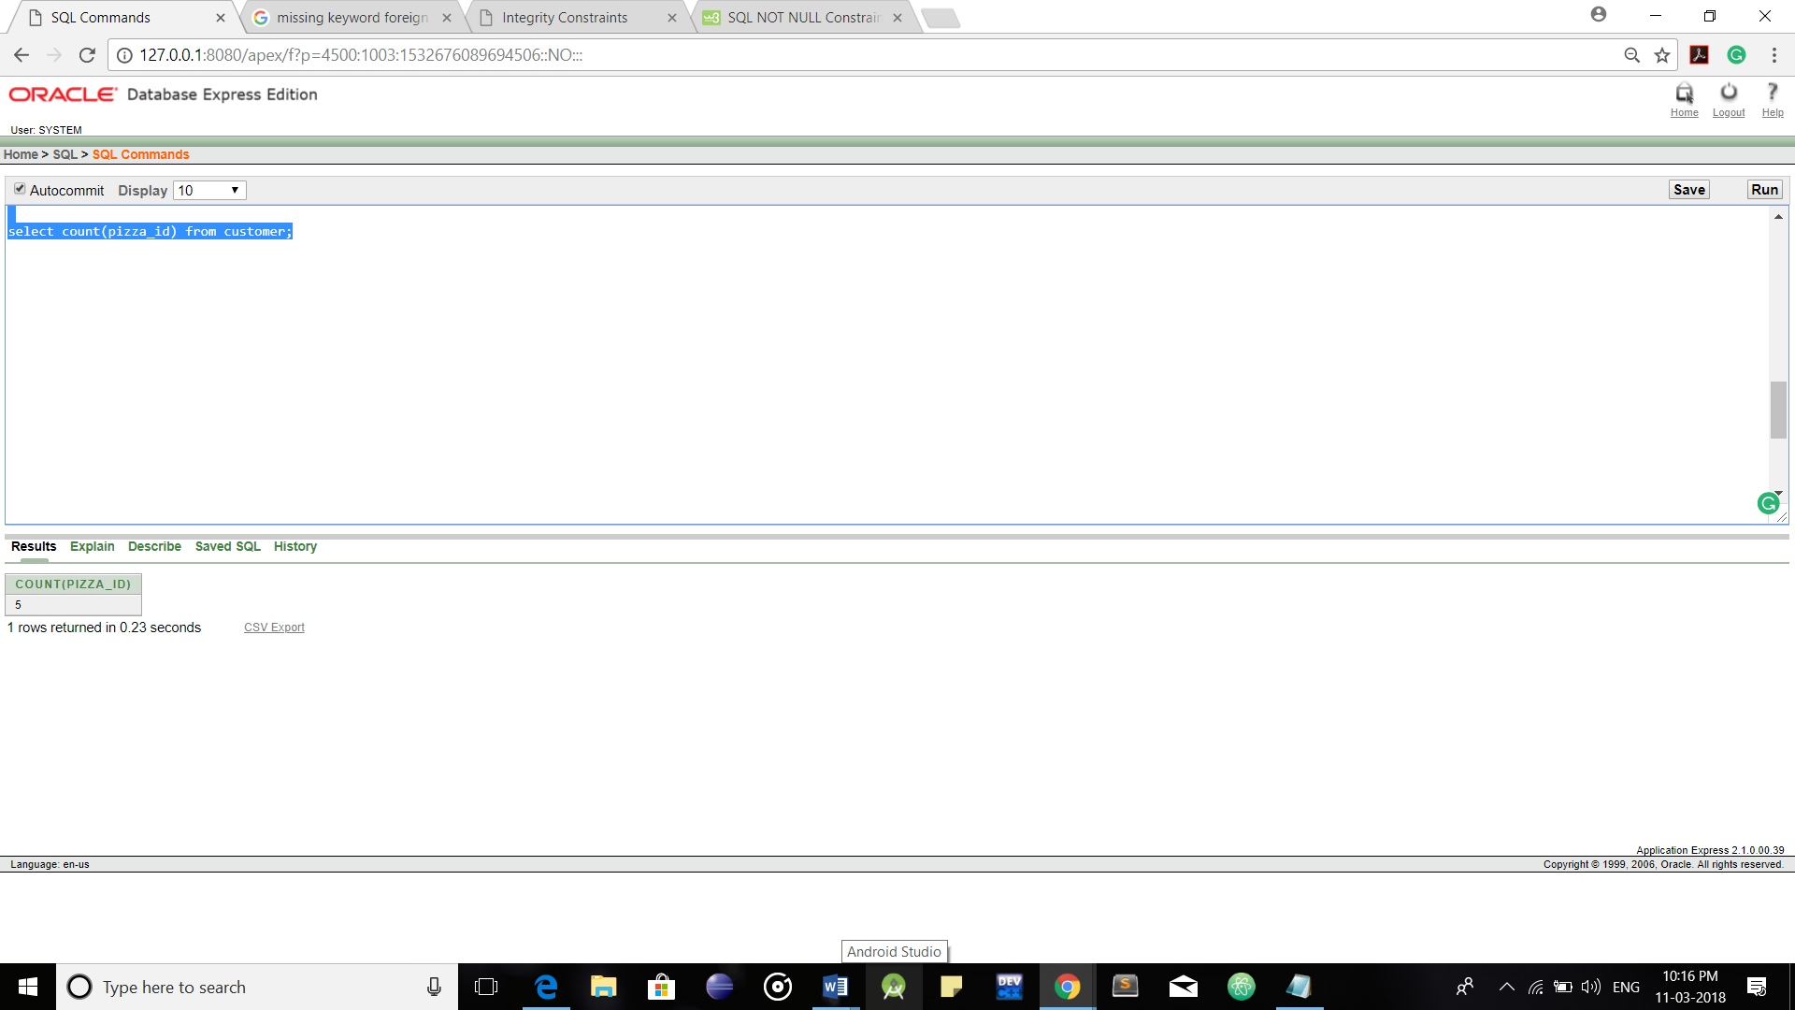

**2)Sum Function:**

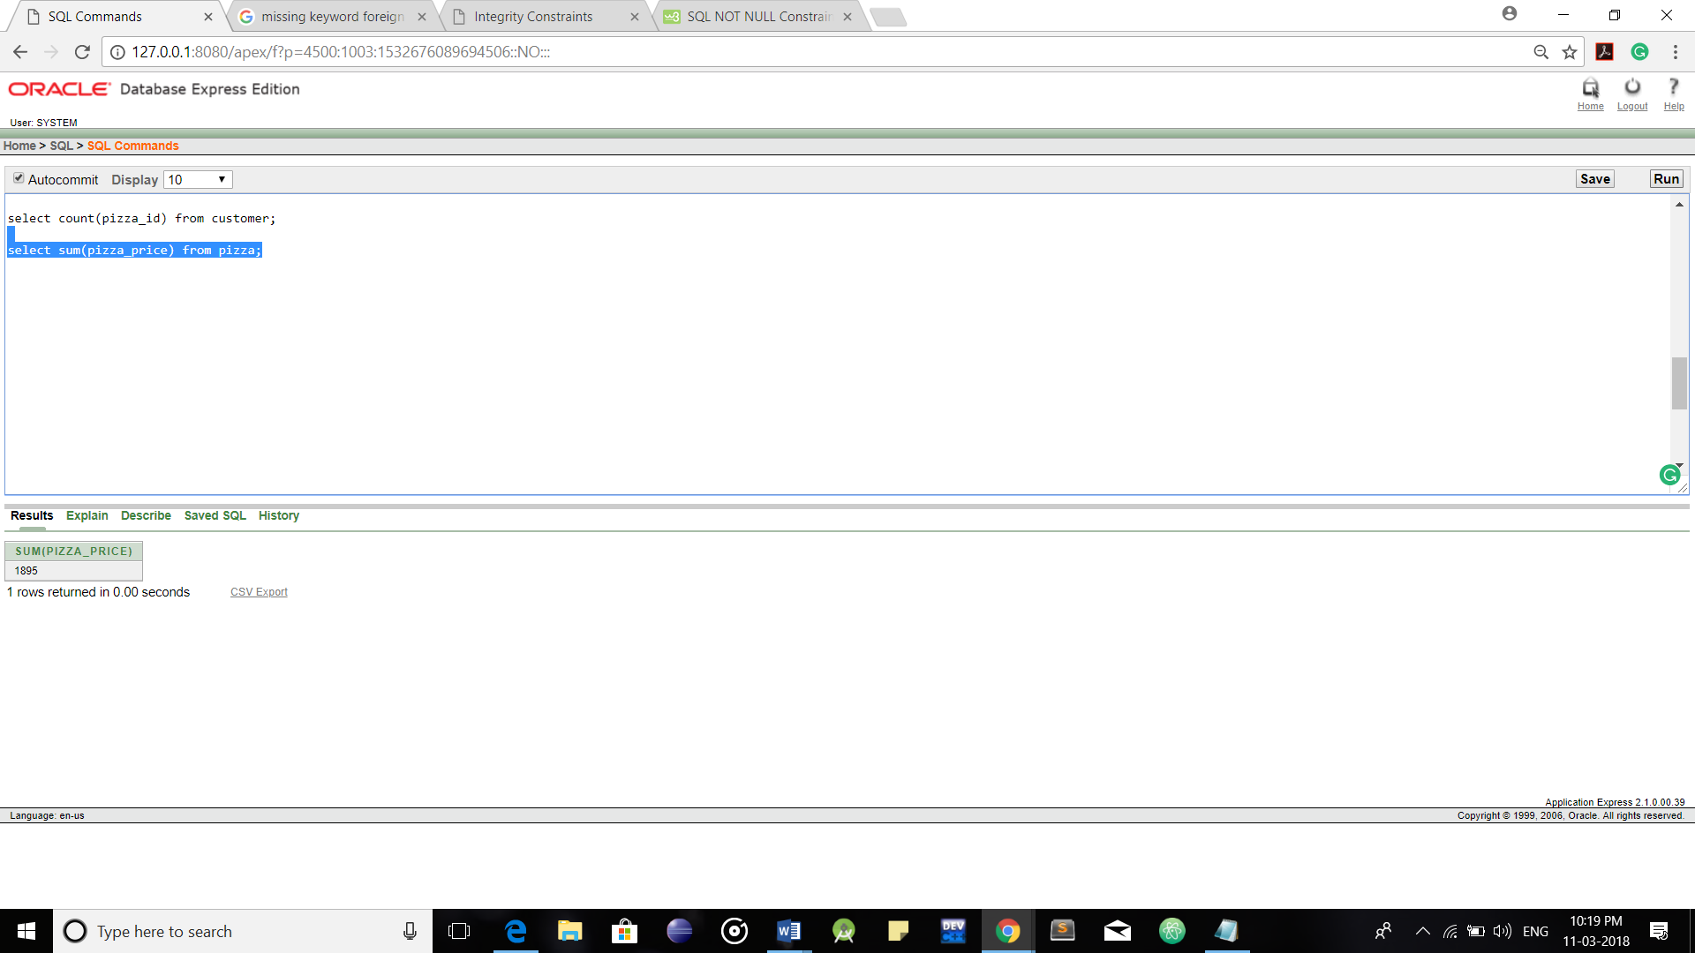

**3)Max/Min:**

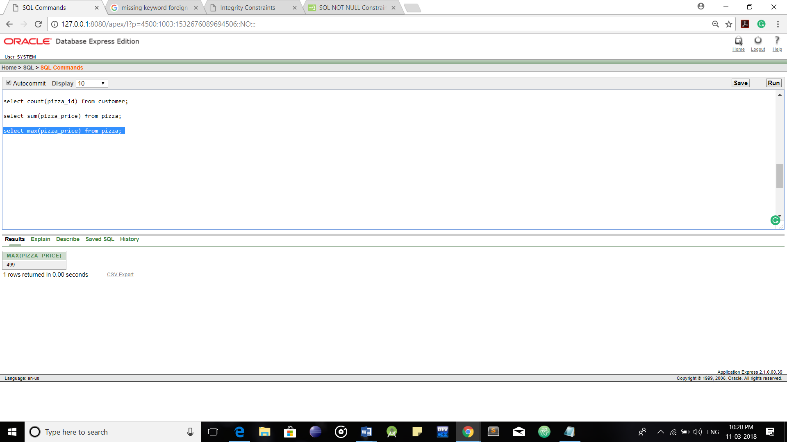

**4)Average:**

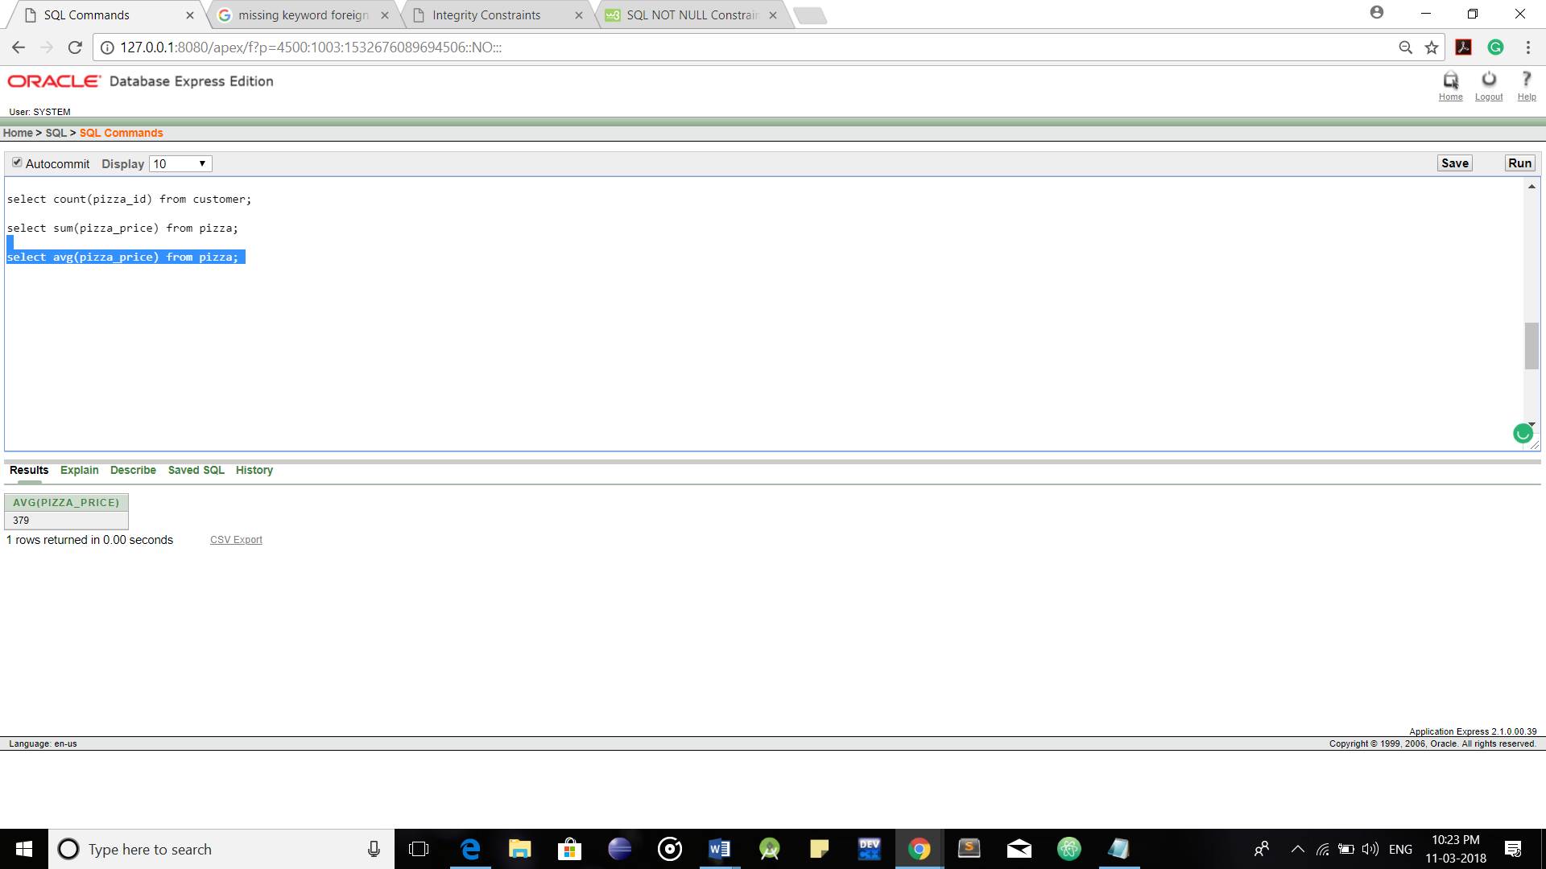

**2.String Functions:**

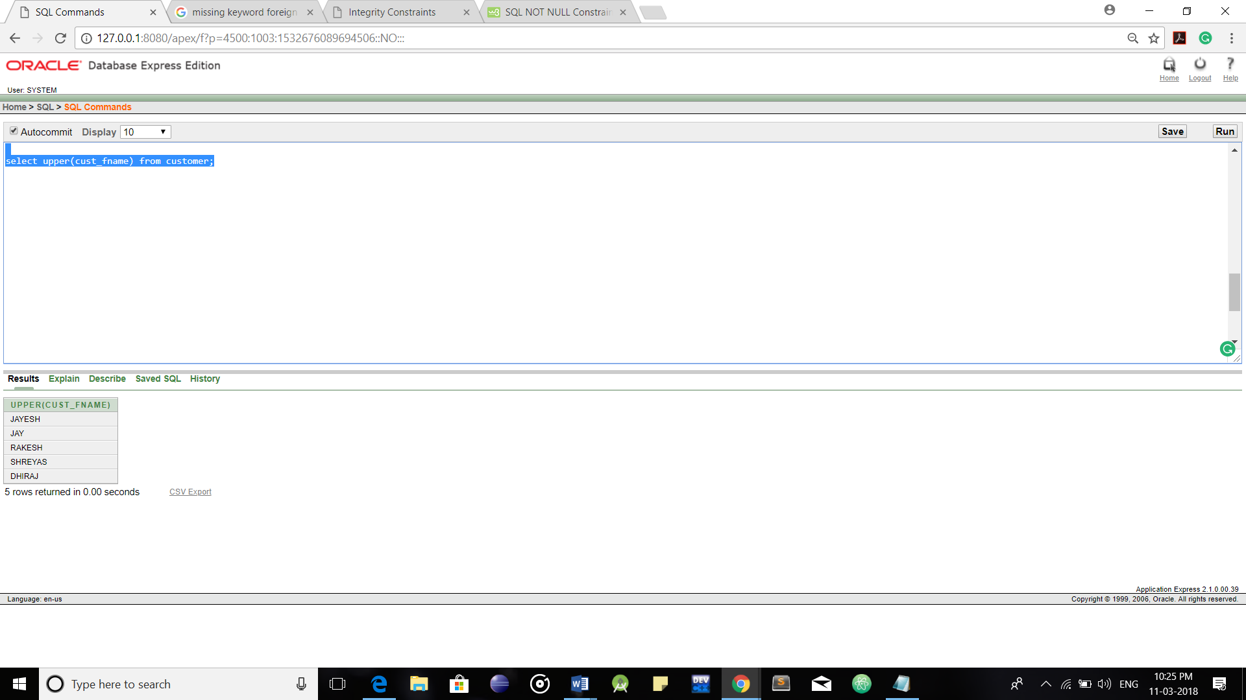

Upper Case

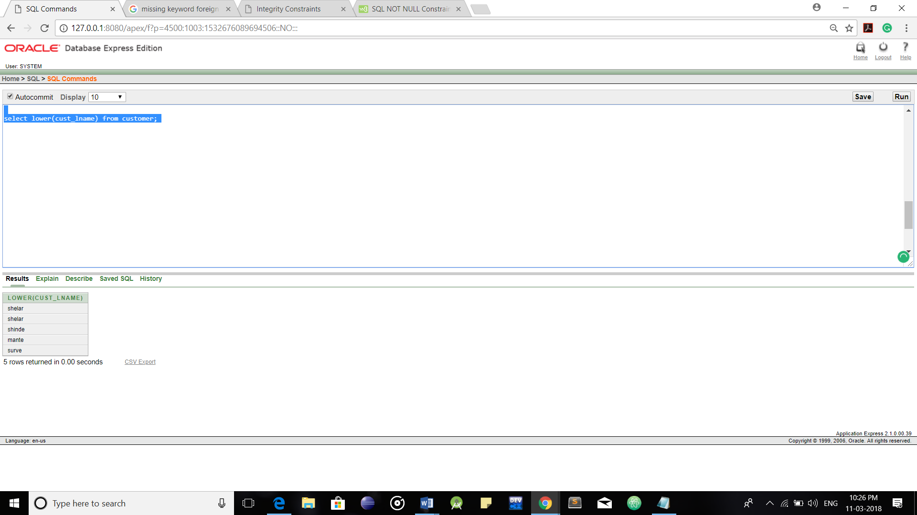

Lower Case

**Clauses:**

**1.Order by Clause:**

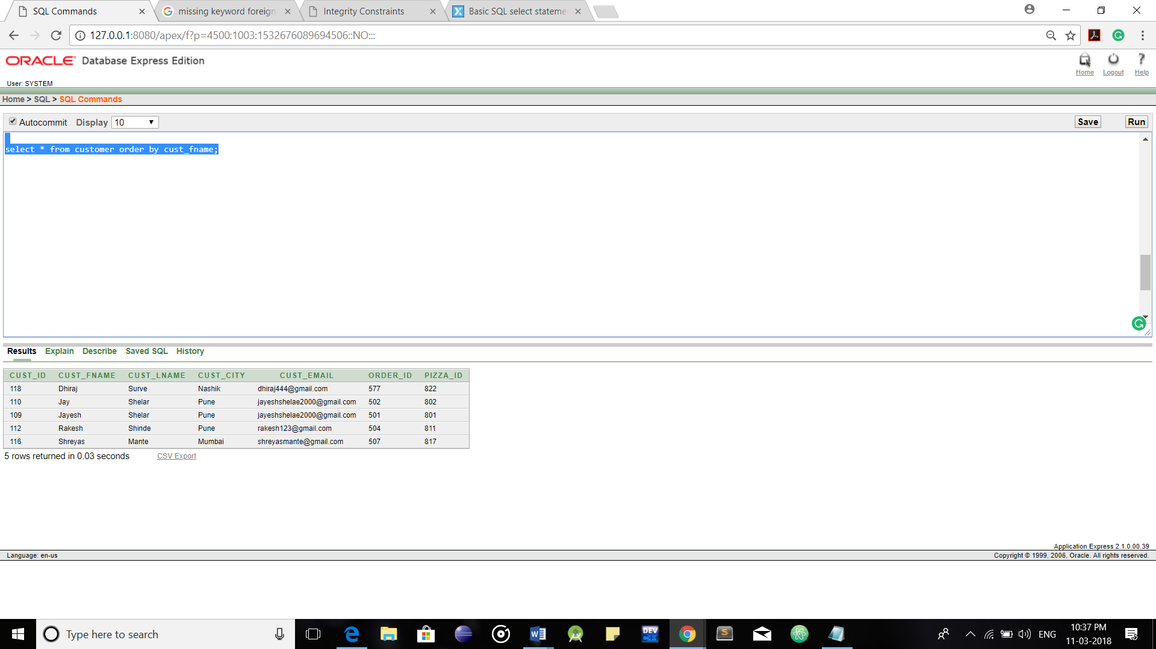

**2.Order by(desc):**

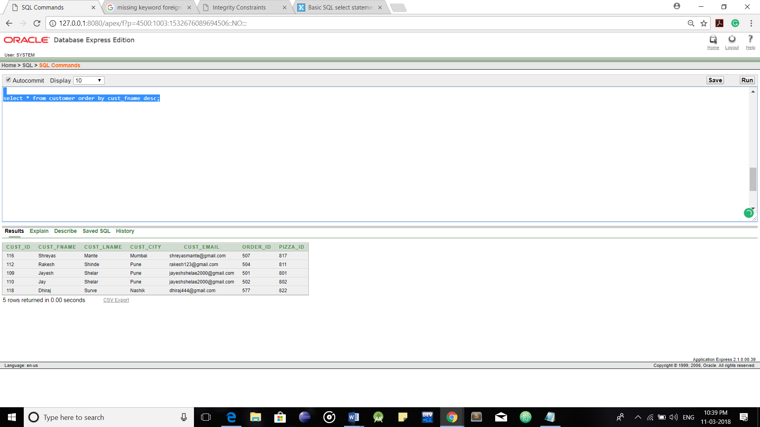

**3.Group by Clause:**

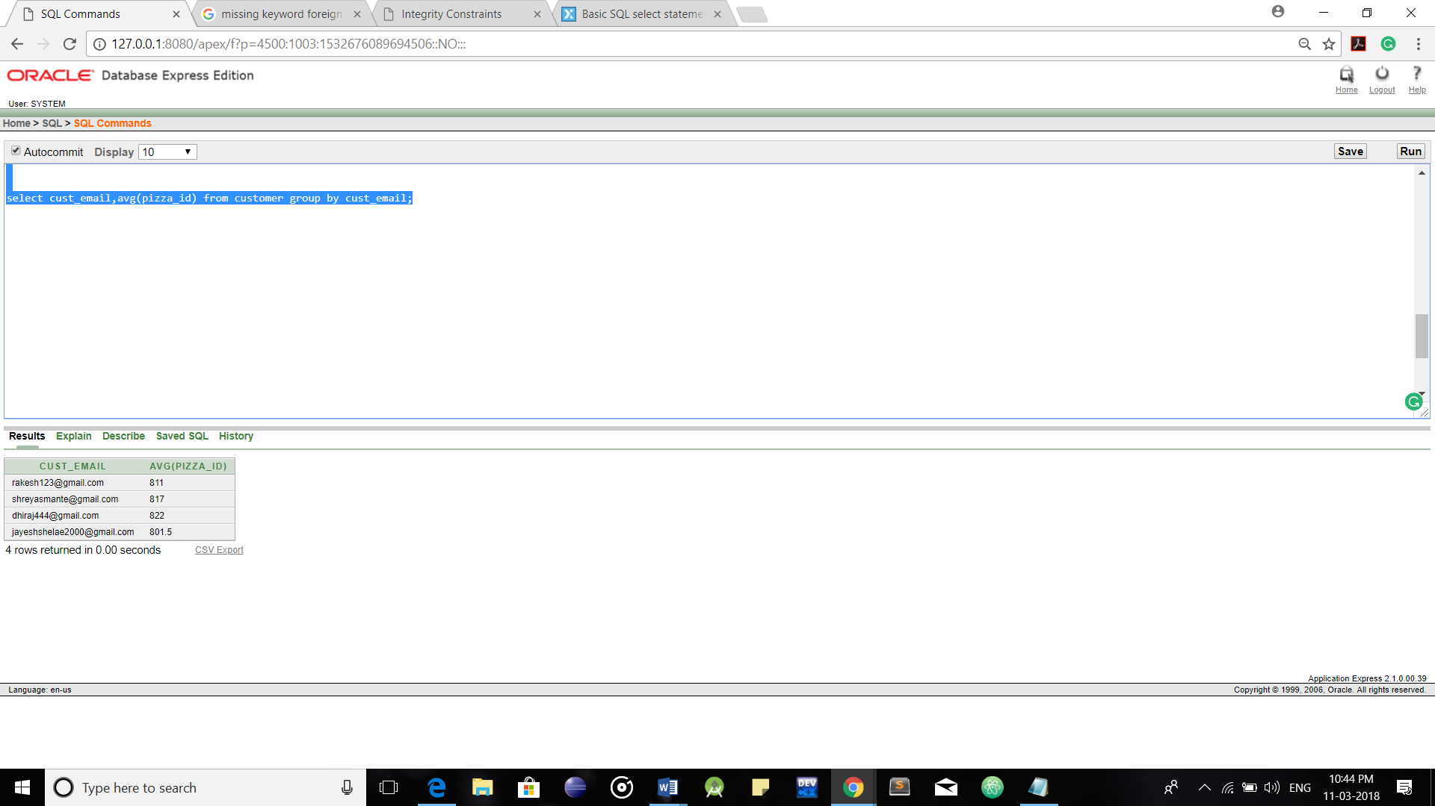

**4.Having Clause:**

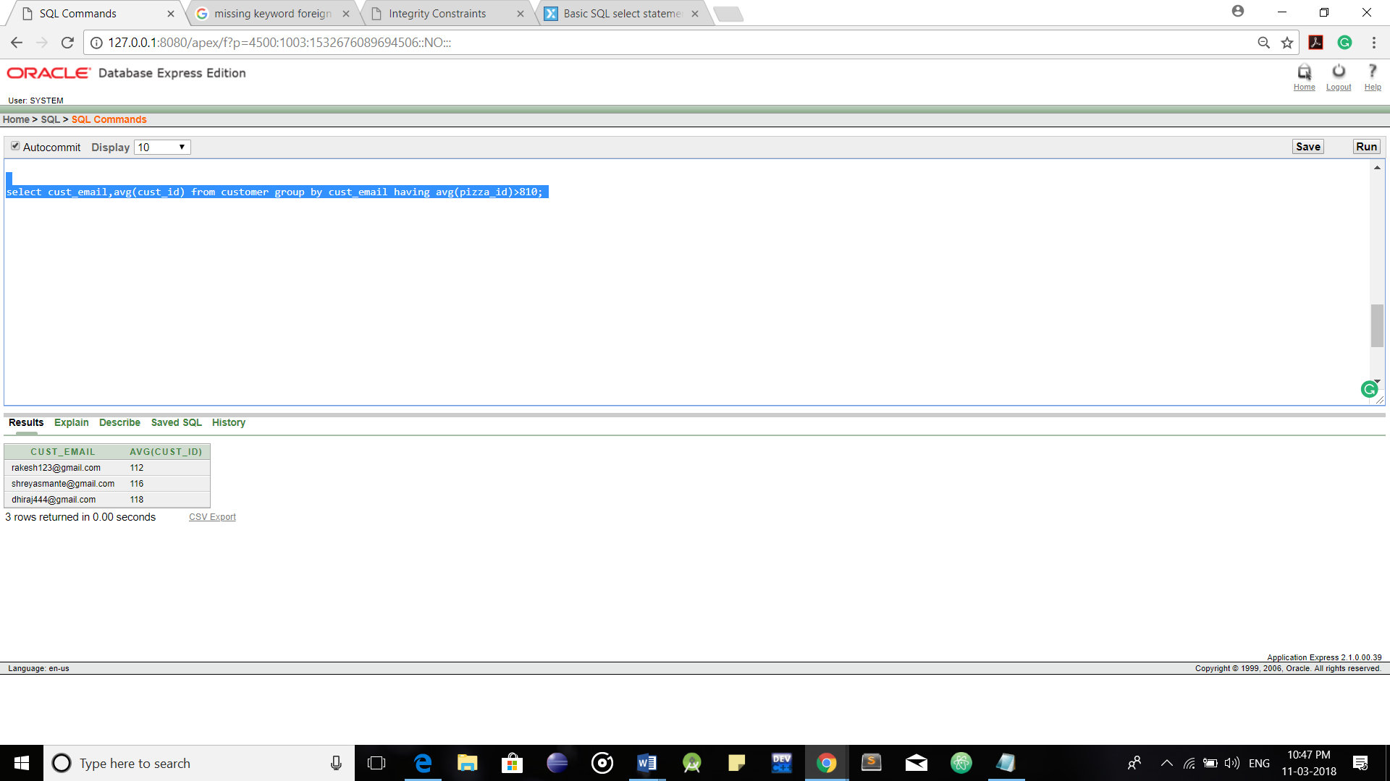

**5.Where Clause:**

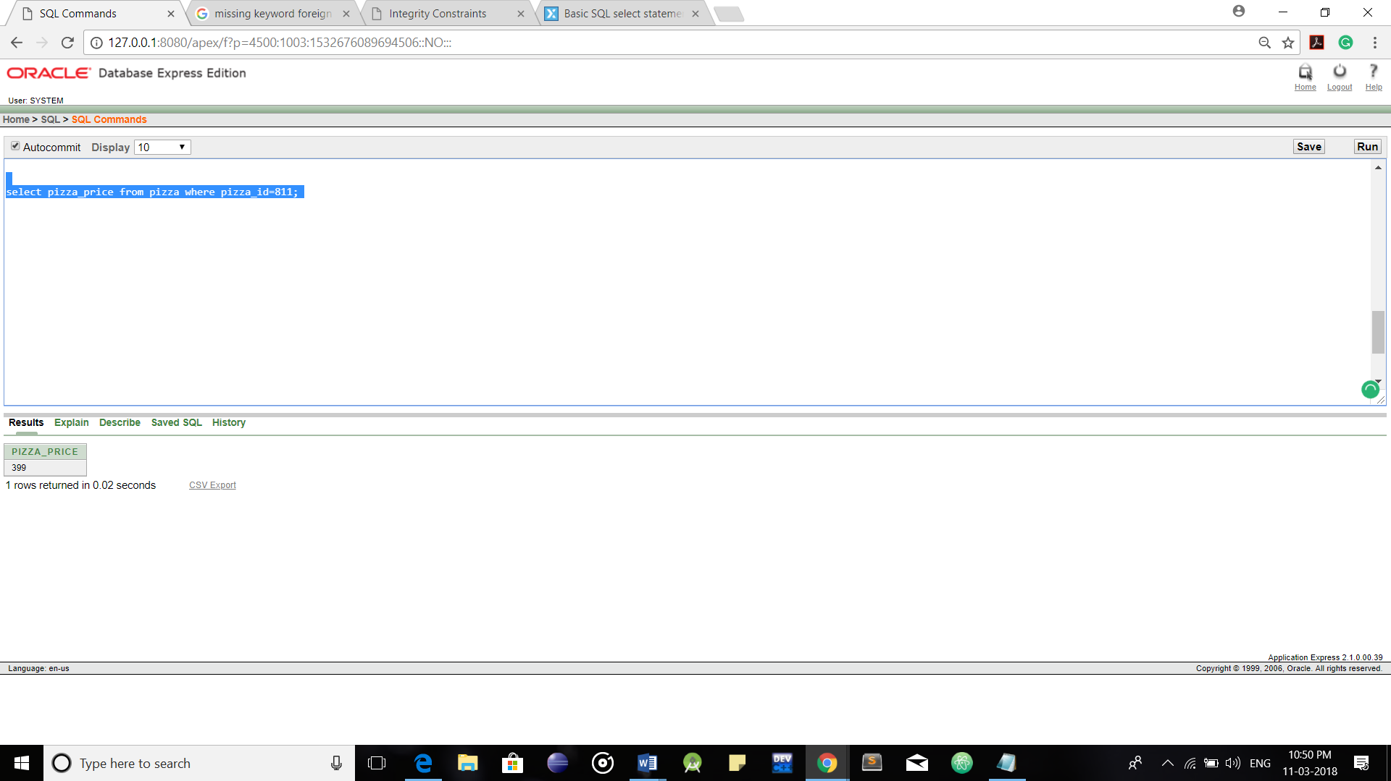

**SQL Joins:**

**1.Cross Join:**

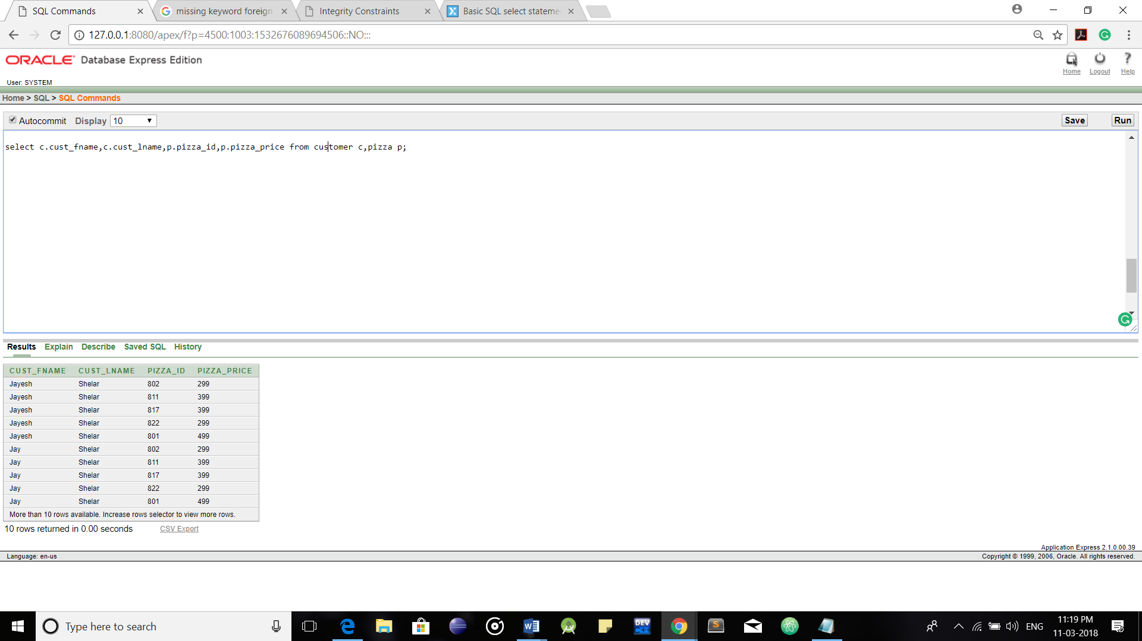

**2.Inner Join:**

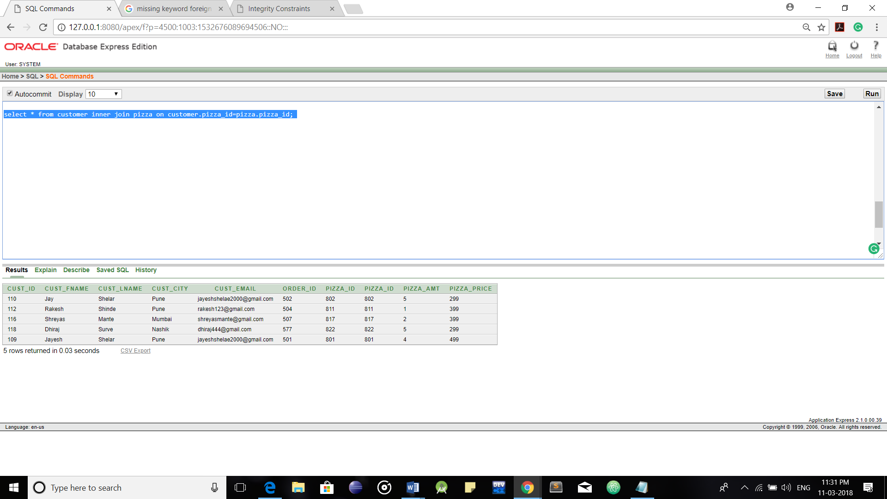

**3.Outer Join(Left):**

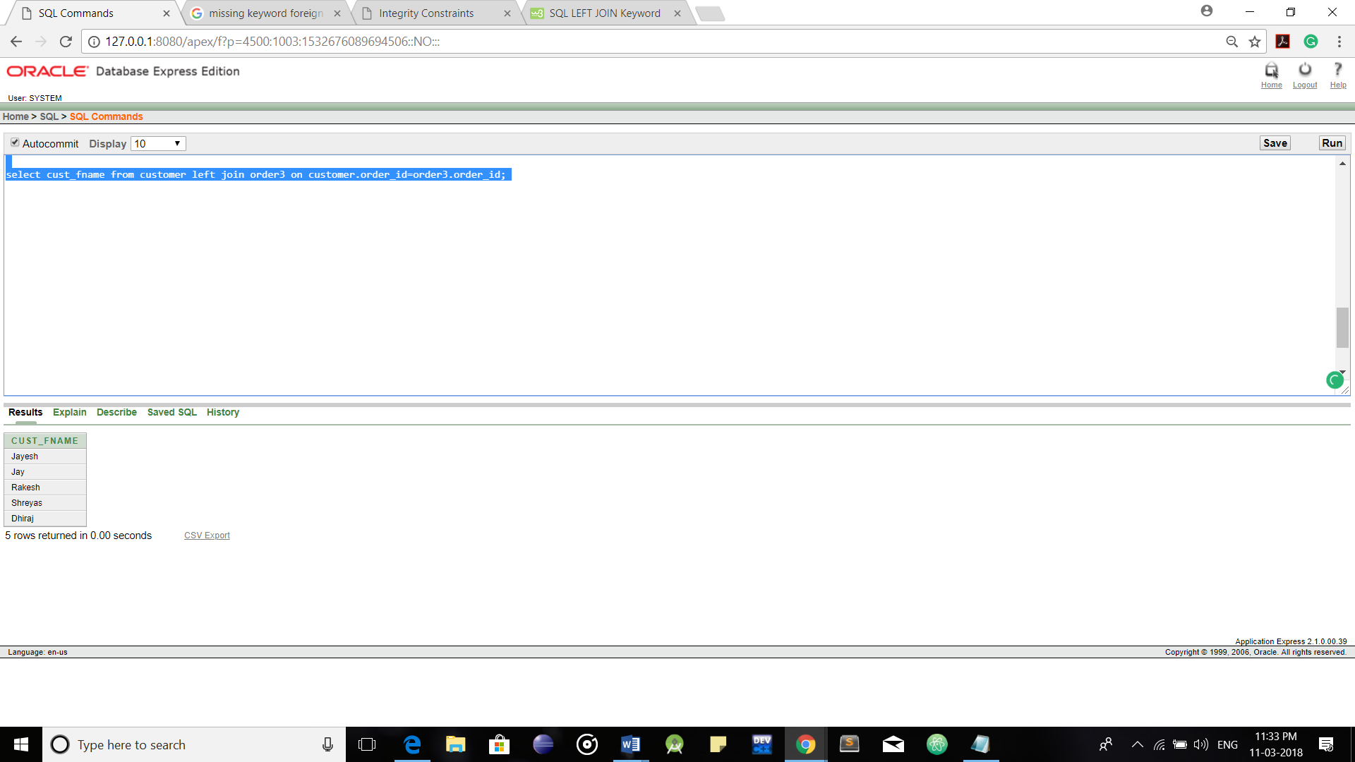

**4.Outer Join(Right):**

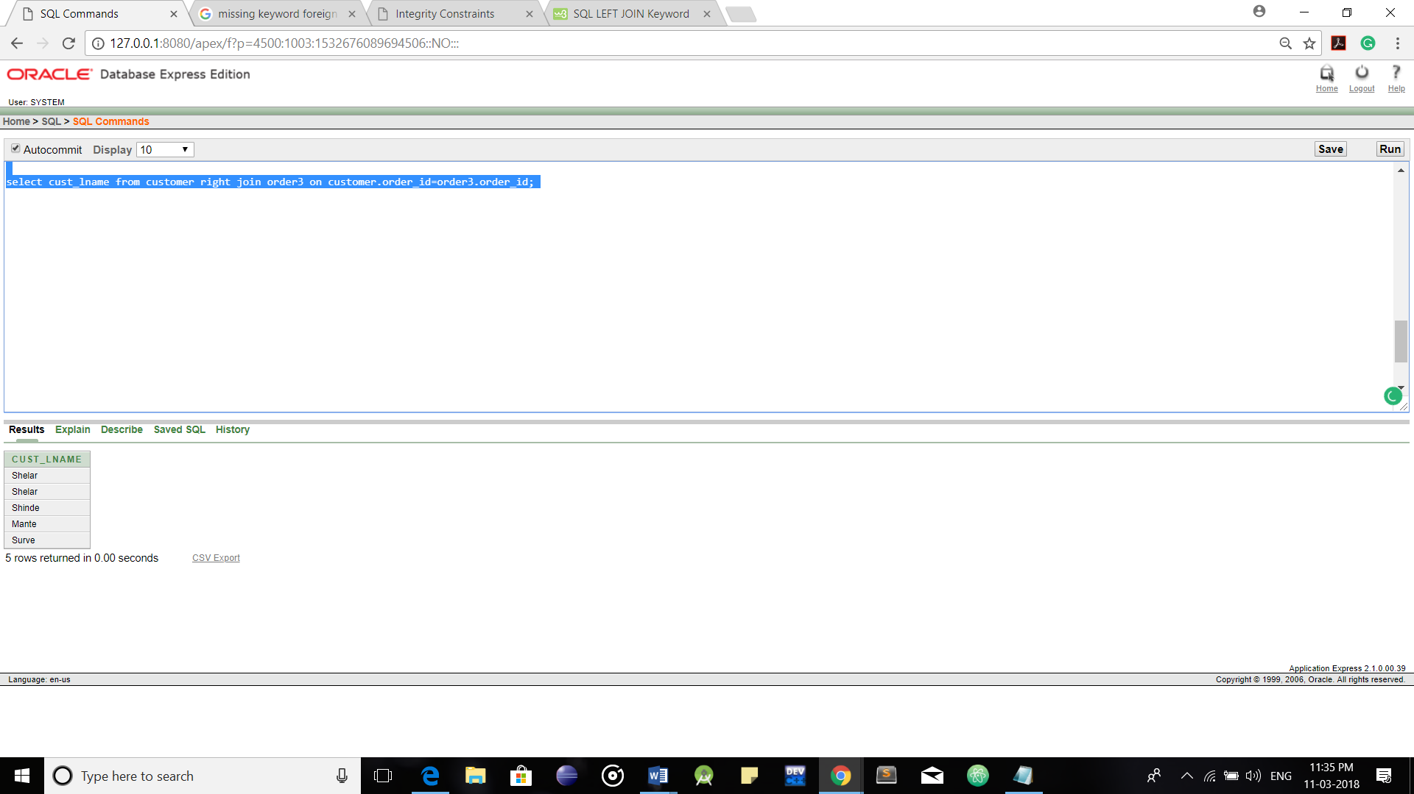

**5.Outer Join(Full):**

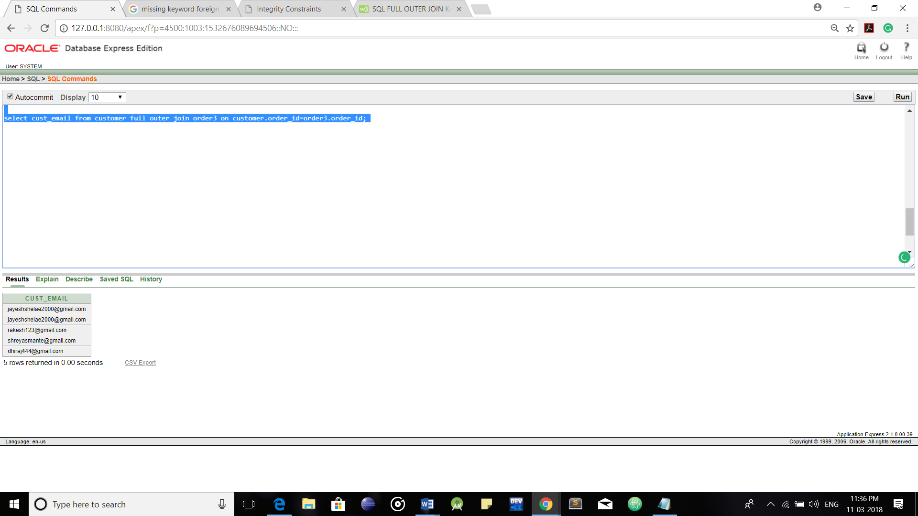

**View:**

**Creating a View:**

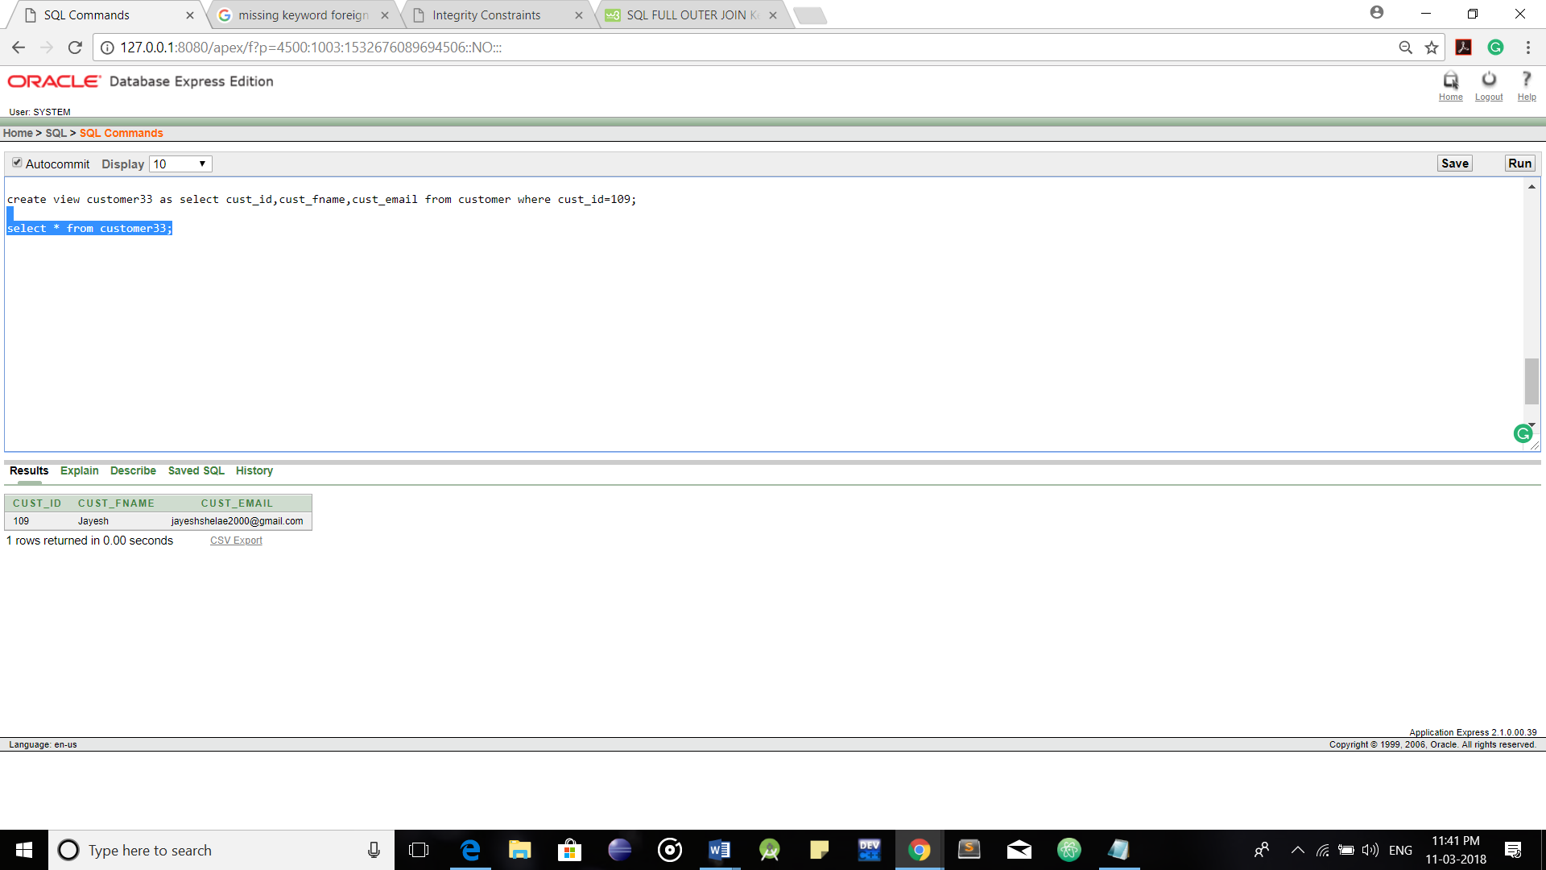

**Updating a View:**

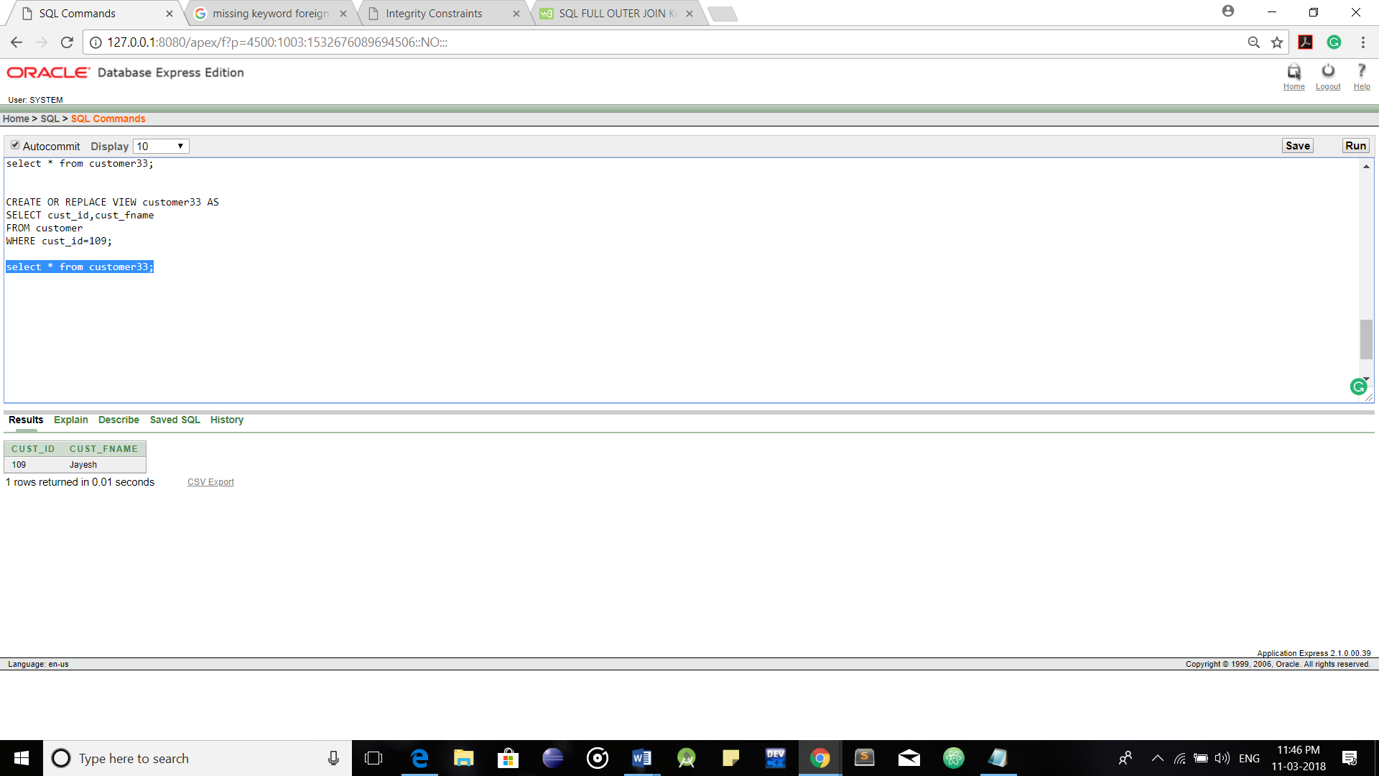

**Dropping a View:**

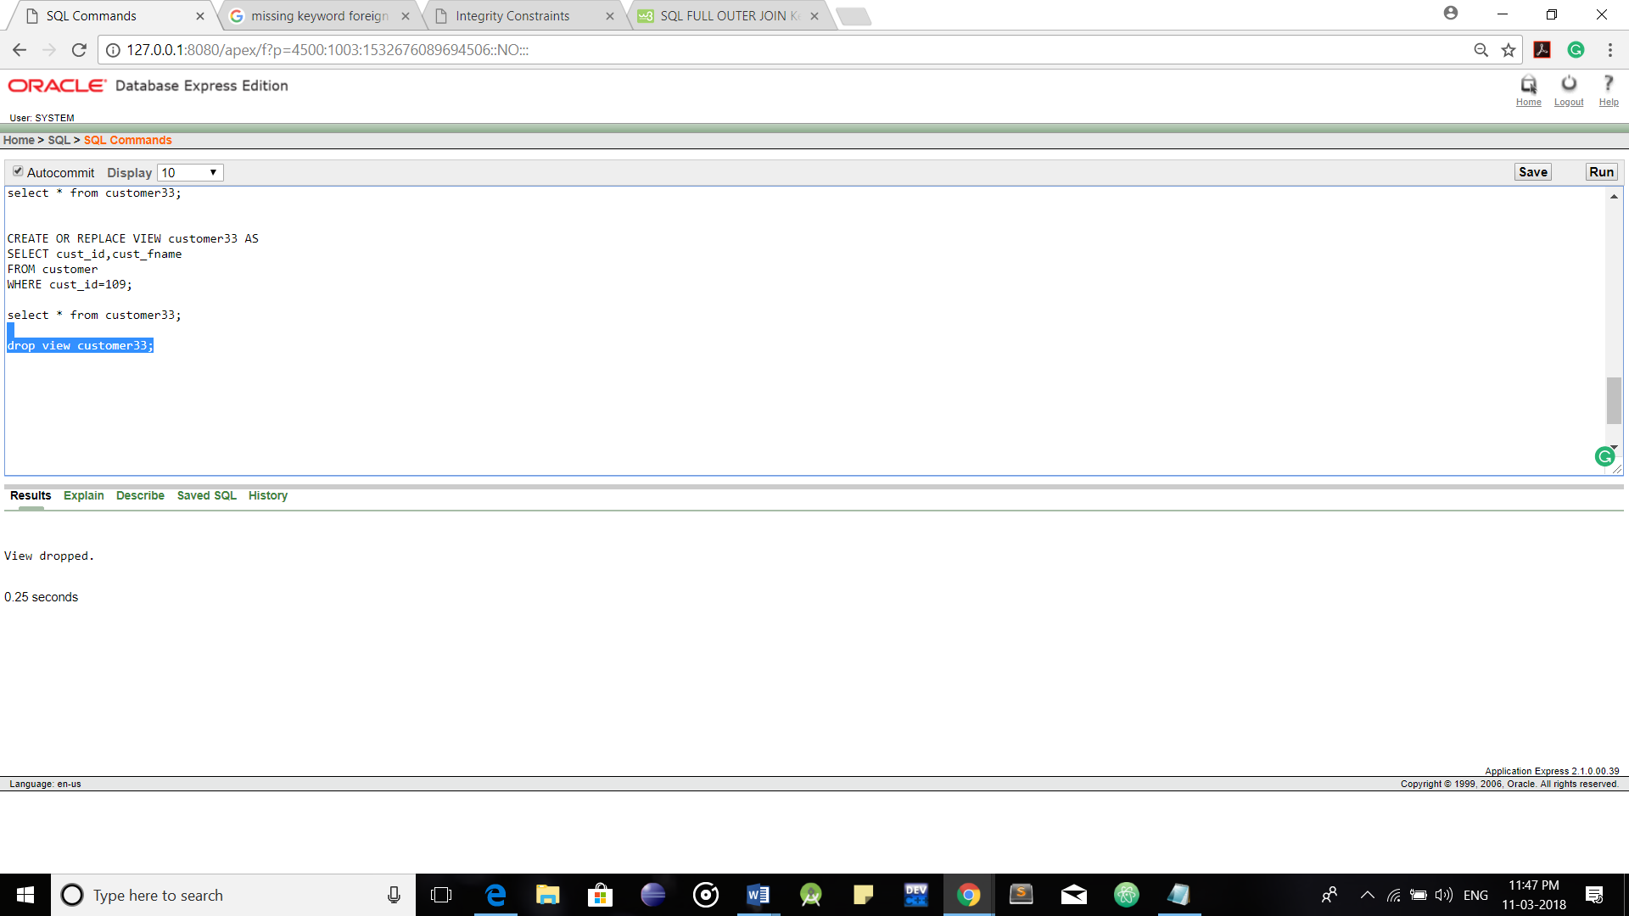

**Index:**

**Creating an Index:**

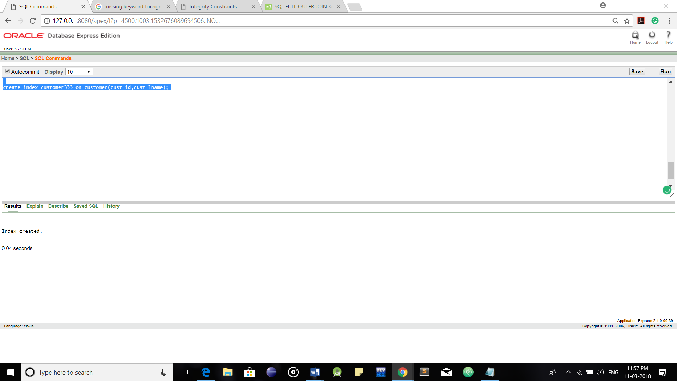

**Dropping an Index:**

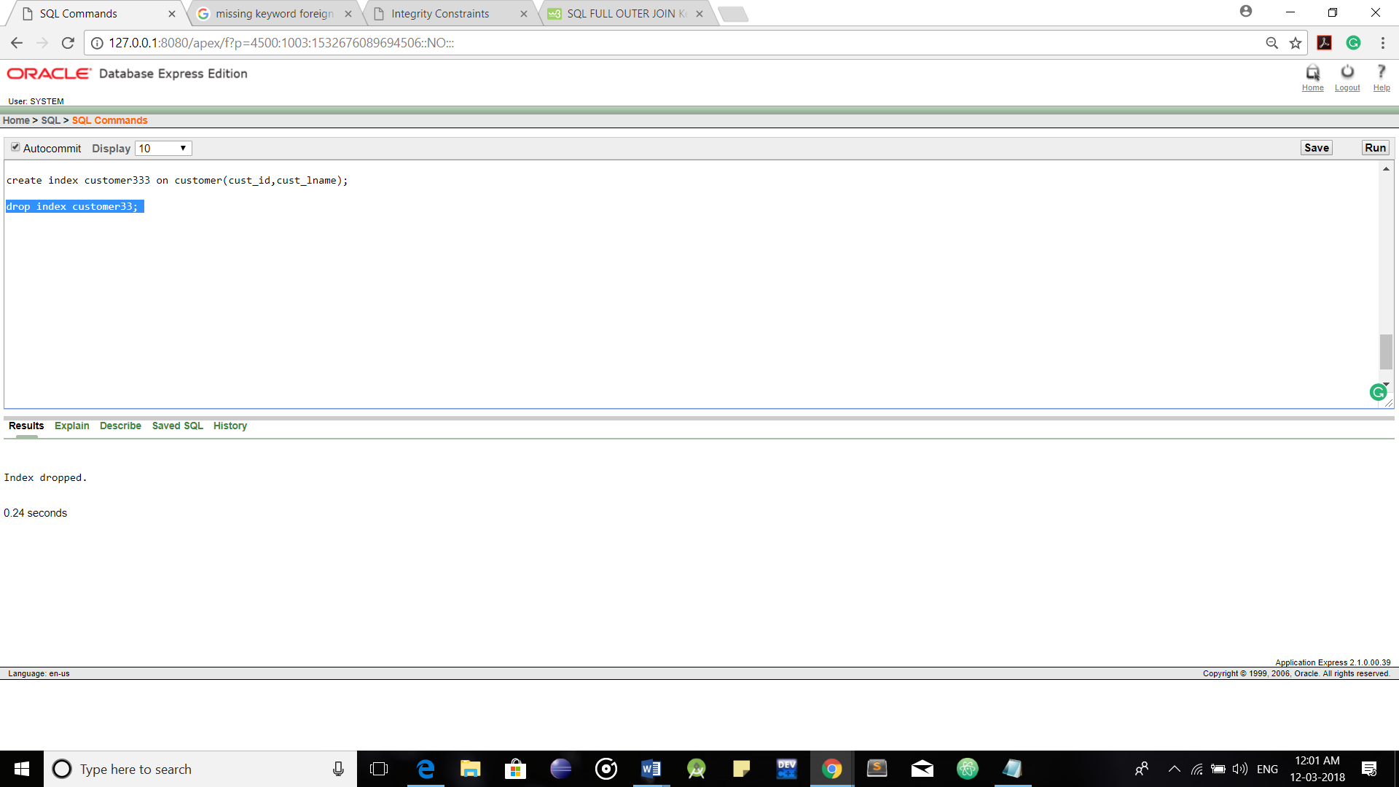

**Sequence:**

**Creating a Sequence:**

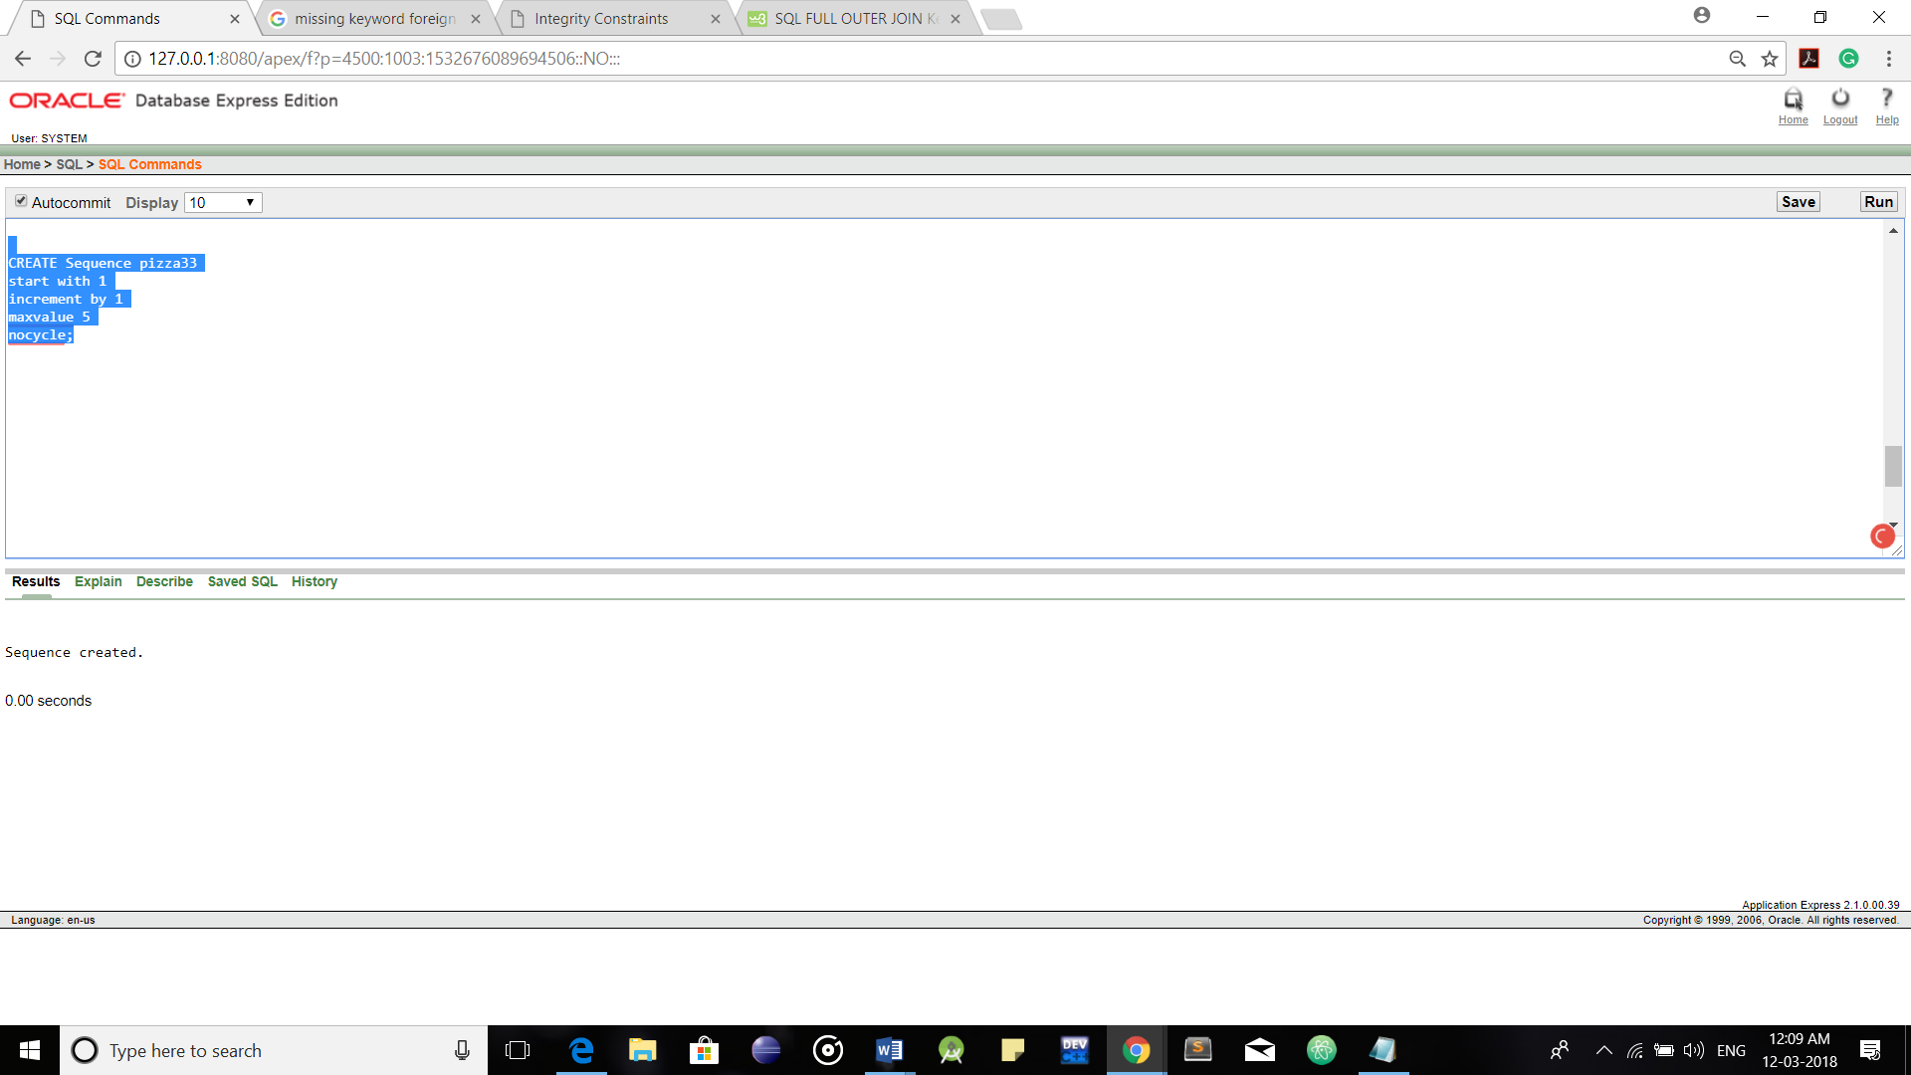

**Trigger:**

Triggers can be defined on the table, view, schema, or database with which the event is associated.

Here, in the table below, when a deletion statement is encountered, the trigger displays the following message i.e the order details of the customer being deleted.

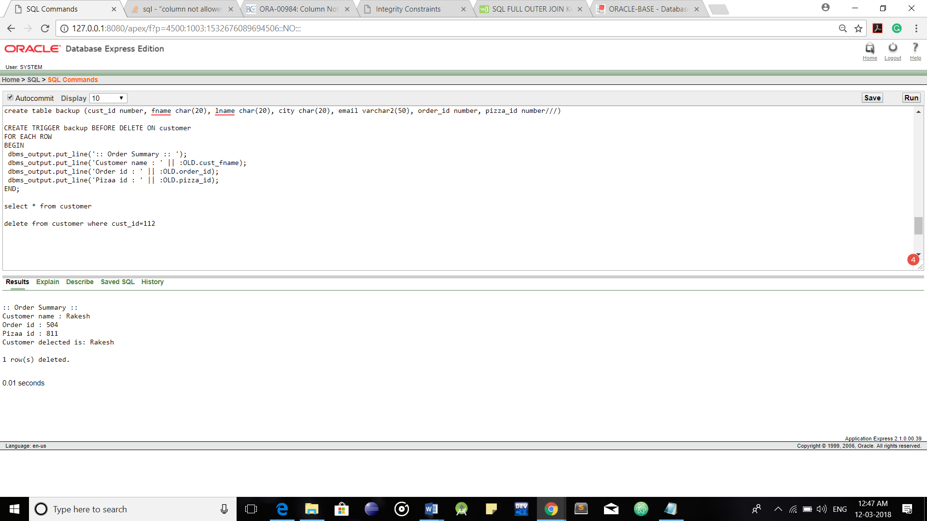

Trigger before a delete operation.

**Cursor and Control Structure:**

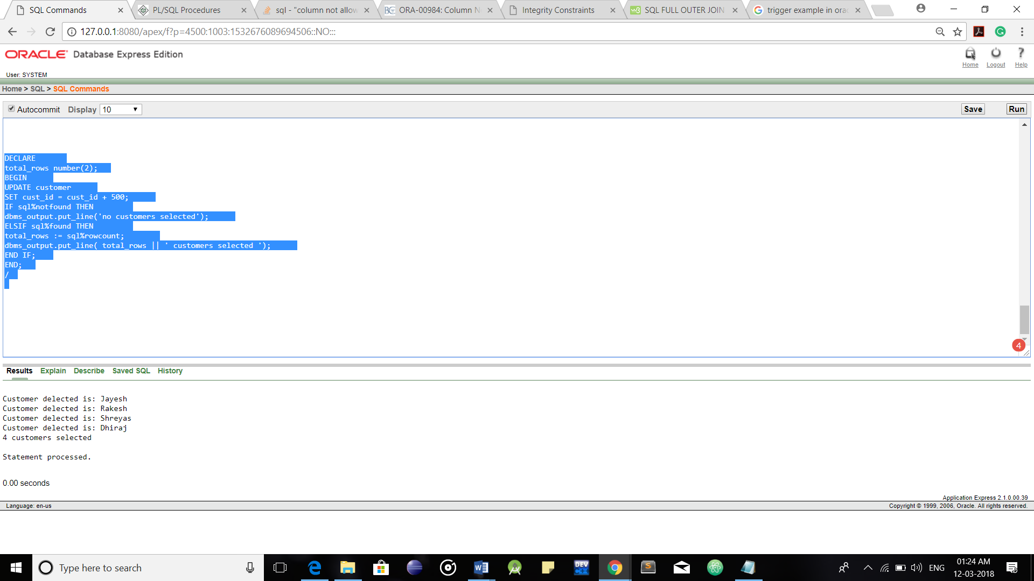

Adding 500 to cust_id if some condition occurs. Cursor, Control Structure are used.

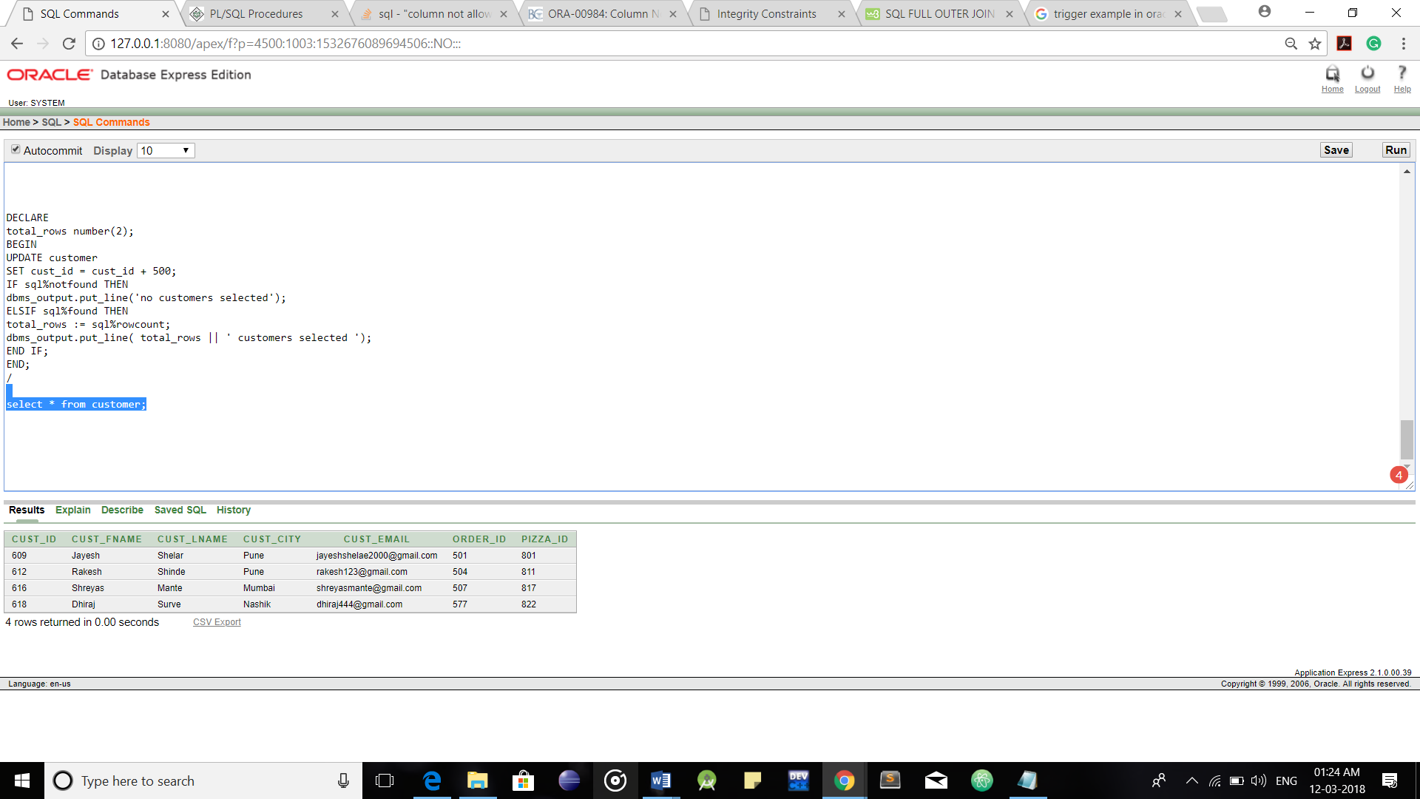

Here you can see that 500 are added to the cust_id in Customer Table.